Reading for Pleasure Suggestions
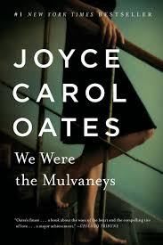
Joyce Carol Oates, We Were The Mulvaneys
A young girl is raped by a high school acquaintance in a very small town, and the fallout affects the lives of everyone in her immediate family.

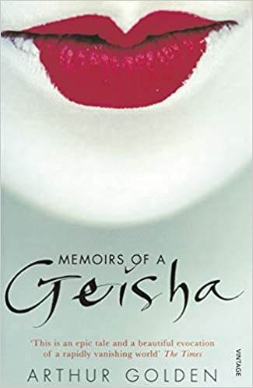
Memoirs of a Geisha, Arthur Golden
In Memoirs of a Geisha, we enter a world where appearances are paramount; where a girl's virginity is auctioned to the highest bidder; where women are trained to beguile the most powerful men; and where love is scorned as illusion. It is a unique and triumphant work of fiction - at once romantic, erotic, suspenseful - and completely unforgettable.

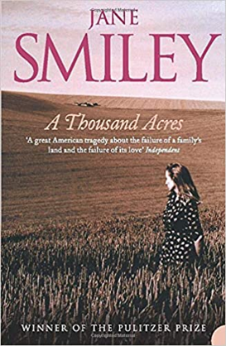
Jane Smiley, A Thousand Acres
The Pulitzer Prize-winning, bestselling novel from one of America’s greatest contemporary writers.
Larry Cook’s farm is the largest in Zebulon County, Iowa, and a tribute to his hard work and single-mindedness. Proud and possessive, his sudden decision to retire and hand over the farm to his three daughters, is disarmingly uncharacteristic.
Ginny and Rose, the two eldest, are startled yet eager to accept, but Caroline, the youngest daughter, has misgivings. Immediately, her father cuts her out.

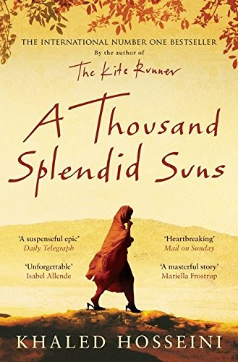
Khaled Hosseini, A Thousand Splendid Suns
Mariam is only fifteen when she is sent to Kabul to marry Rasheed. Nearly two decades later, a friendship grows between Mariam and a local teenager, Laila, as strong as the ties between mother and daughter. When the Taliban take over, life becomes a desperate struggle against starvation, brutality and fear. Yet love can move a person to act in unexpected ways, and lead them to overcome the most daunting obstacles with a startling heroism.

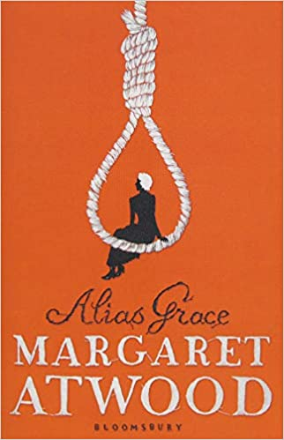
Margaret Atwood, Alias Grace
It's 1843, and Grace Marks has been convicted for her involvement in the vicious murders of her employer and his housekeeper and mistress. Some believe Grace is innocent; others think her evil or insane. Now serving a life sentence, Grace claims to have no memory of the murders.

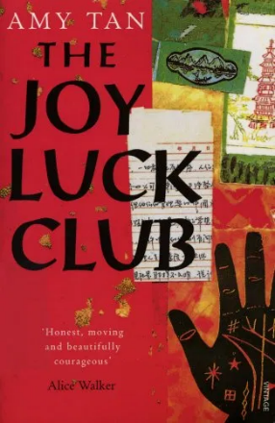
Amy Tan, The Joy Luck Club
The Joy Luck Club describes the lives of four Asian women who fled China in the 1940s and their four very Americanized daughters. The novel focuses on Jing-mei "June" Woo, a thirty-six-year-old daughter, who, after her mother's death, takes her place at the meetings of a social group called the Joy Luck Club

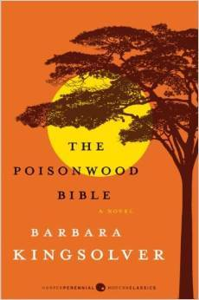
Barbara Kingsolver, The Poisonwood Bible
In 1959 an overzealous Baptist minister named Nathan Price drags his wife and four daughters deep into the heart of the Congo on a mission to save the unenlightened souls of Africa. The five women narrate the novel. From the outset, the attitudes of the five women cover a wide spectrum.

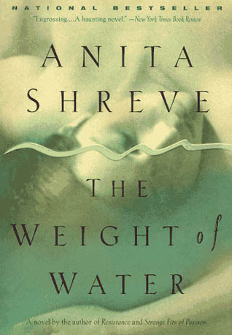
Anita Shreve, The Weight of Water
A newspaper photographer, Jean, researches the lurid and sensational murder of two women in 1873 as an editorial tie-in with a brutal modern double murder. She discovers a cache of papers that appear to give an account of the murders by an eyewitness. The plot weaves between the narrative of the eyewitness and Jean's private struggle with jealousies and suspicions as her marriage teeters. A rich, textured novel.

Alice Walker, The Colour Purple
Set in the deep American South between the wars, THE COLOR PURPLE is the classic tale of Celie, a young black girl born into poverty and segregation. Raped repeatedly by the man she calls 'father', she has two children taken away from her, is separated from her beloved sister Nettie and is trapped into an ugly marriage. But then she meets the glamorous Shug Avery, singer and magic-maker - a woman who has taken charge of her own destiny. Gradually Celie discovers the power and joy of her own spirit, freeing her from her past and reuniting her with those she loves.
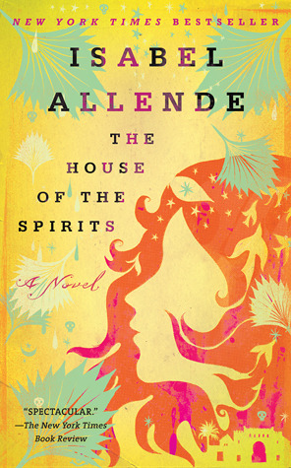
Isabel Allende, The House of Spirits
The House of the Spirits is a family saga that spans four generations, but focuses primarily on the lives of two women in the clan, Clara del Valle and Alba de Satigny, and the connection between them.

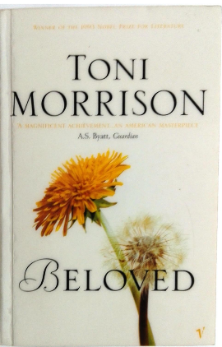
Toni Morrison, Beloved
The novel examines the destructive legacy of slavery as it chronicles the life of a black woman named Sethe, from her pre-Civil War days as a slave in Kentucky to her time in Cincinnati, Ohio, in 1873. Although Sethe lives there as a free woman, she is held prisoner by memories of the trauma of her life as a slave.

Angela Carter, The Bloody Chamber and Other Stories
In The Bloody Chamber, Carter spins subversively dark and sensual versions of familiar fairy tales and legends like "Little Red Riding Hood," "Bluebeard," "Puss in Boots," and "Beauty and the Beast," giving them exhilarating new life in a style steeped in the romantic trappings of the gothic tradition.

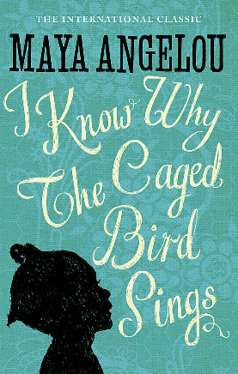
Maya Angelou, I Know Why the Caged Bird Sings
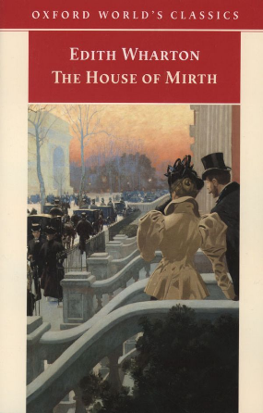
Sent by their mother to live with their devout, self-sufficient grandmother in a small Southern town, Maya and her brother, Bailey, endure the ache of abandonment and the prejudice of the local "powhitetrash." At eight years old and back at her mother’s side in St. Louis, Maya is attacked by a man many times her age—and has to live with the consequences for a lifetime. Years later, in San Francisco, Maya learns that love for herself, the kindness of others, her own strong spirit, and the ideas of great authors ("I met and fell in love with William Shakespeare") will allow her to be free instead of imprisoned.
Edith Wharton, The House of Mirth
Lily Bart, beautiful, witty and sophisticated, is accepted by New York’s 'old money' and courted by the growing tribe of nouveaux riches. But as she nears thirty, her foothold becomes precarious; a poor girl with expensive tastes, she needs a husband to preserve her social standing, and to maintain her in the luxury she has come to expect. Whilst many have sought her, something - fastidiousness or integrity- prevents her from making a 'suitable' match.

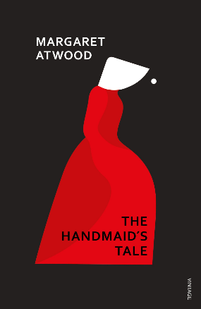
Margaret Atwood, The Handmaid's Tale
Offred is a Handmaid in the Republic of Gilead. She may leave the home of the Commander and his wife once a day to walk to food markets whose signs are now pictures instead of words because women are no longer allowed to read. She must lie on her back once a month and pray that the Commander makes her pregnant, because in an age of declining births, Offred and the other Handmaids are valued only if their ovaries are viable. Offred can remember the years before, when she lived and made love with her husband, Luke; when she played with and protected her daughter; when she had a job, money of her own, and access to knowledge. But all of that is gone now . . .

