L’introduction du français au niveau A-Level.

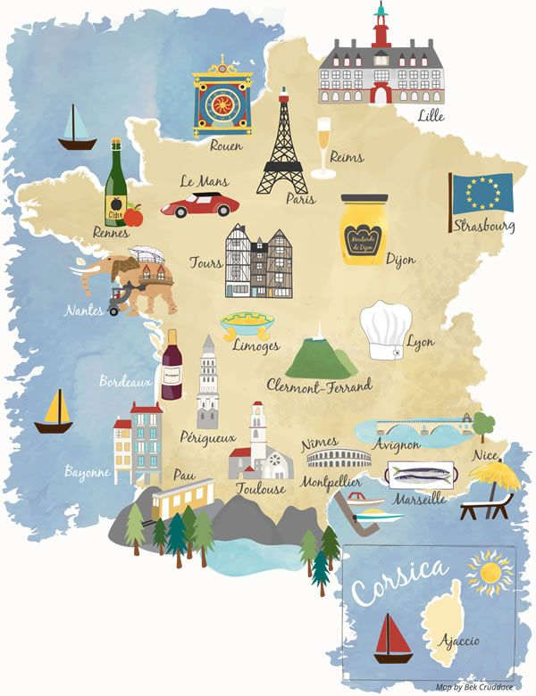

Travail d’été
How to prepare for French at A Level
You have a few weeks in which to really prepare for your A Level in French. The leap from GCSE to A Level is significant. This booklet contains links to a range of media, most of which is available for free online as well as tasks to complete before the start of term. In order to keep pace, it is vital that you work through the tasks. Little and often…

Watch…

TELEVISION
• http://www.tv5monde.com/ Watch this channel to gain access to the last episodes of all of their TV shows. Check out their French language learning section at http://apprendre.tv5monde.com/ where you can watch clips and answer comprehension questions on what you have seen with accompanying grammar exercises iPad /tablet– search in the App Store for M6. This is a popular French TV channel. Not all programmes are available outside of France, but there is a good selection and these help with listening skills.

MOVIES
• La Haine
• Au Revoir les Enfants, dir. Louis Malle (1987)
•Chocolat, dir. Claire Denis (1988)
• Cléo de 5 à 7, dir. Agnès Varda (1962)
• La Vie en Rose, dir. Olivier Dahan (2007)
- L’Auberge espagnole, dir Cédric Klapish (2002)
• Les Choristes, dir. Christophe Barratier (2004) • Les 400 Coups, dir. François Truffaut (1959)

LISTEN TO THE RADIO
The great thing about listening to the radio is that you can get on with something else at the same time. Listen live using the Radio France or the Europe 1. It sometimes takes a while to buffer so be patient.

• Radio France (www.radiofrance.fr) • Europe 1 (www.europe1.fr)
• Le mouv (www.mouv.fr) (this is the French equivalent to Kiss FM or Capital) • Europe 2 (www.europe2.fr)

Read…
Keep your own vocabulary book for new expressions you come across – there is a sheet at the back of this booklet to start you off. Or you can ask your teacher for a small vocab booklet to fill in as you go. You could order it alphabetically, by topic area based on what we are going to study or just use it as a diary and scribble away your French development in it.

NEWSPAPERS AND MAGAZINES
Read a foreign language newspaper – Le Figaro is available in larger paper shops. Le Figaro has its own website http://www.lefigaro.fr/ so that you can read the paper online. You do not have to read the paper cover to cover, just scan the headlines and pick out ONE article that grabs your attention.

This website gives you access to newspapers all over the world. Here is the link to a range of French papers. http://www.mediatico.com/en/newspapers/europe/france/national/

This website is a more light-hearted newspaper which covers global stories as well as gossip. http://www.20minutes.fr. Also try http://www.20minutos.fr/tv/ . This is the TV Channel for this newspaper.

In Spain there is also a news website for young people: www.l-eco.fr . It has sections on the Internet and Mobile Technology; Science and Wildlife; Education; Culture; Sport; Society and Health. A glance today contained articles about Facebook, video games and bullying to name but a few.

To catch up on the latest gossip and to see what the celebs are wearing, take a look at www.elle.fr.

Websites
Switch to French browsers such as and http://fr.yahoo.com/ or www.yahoo.fr as well as www.google.fr. This way, you will read French every time you log on and it will become part of your everyday activity.

Look at the BBC website http://www.bbc.co.uk/languages/french/tv for links to French programmes available on line.

Language skills: this website is free after 4pm and really comes into its own with its A level section. Watch news video clips, find theme related vocabulary and do listening and reading comprehensions. Find it here http://zut.languageskills.co.uk/advanced/year12.html

Websites for research
Once you actually start your A Level in September, you will realise that you are almost completing a Sociology A Level in French. It is fascinating and you will learn all about the history and culture of French speakers. Here are some websites bursting with information about France and Francophone countries. Always start your research with these websites as it is easy to get bogged down when looking for help on the internet.

If you are searching for information, try switching to the French www.fr.wikipedia. Remember that anyone can write on Wikipedia so you
must validate your research elsewhere and never quote from it! It is a good place to start though.

A French government run website: http://www.gouvernement.fr/

A website in English with some great links to various topics: http://french.about.com/

British Council support available from http://schoolsonline.britishcouncil.org/ Keep your eyes peeled as they often have trips to France for free! You have to apply for them but they are an amazing opportunity to build your French skills. There is no better way to learn a language than by spending time in that country.

On-line dictionary
A good on-line dictionary is: http://www.wordreference.com/

TOP TIP: Don’t look up every word you are not sure of when reading an article/ book

Yes… you read that right. When you are reading articles etc, try not to look up every word as it will take you forever. Skim and scan the text to get the gist. Remember to use the context or the article, cognates and common sense to figure out what the article is saying. Pick out a couple of words that you like the look of, that you feel may be real hurdles to getting the idea of the text, look them up carefully and add them to your vocab booklet. The aim at this stage is to get the gist of the article, not be able to translate it completely. Translation is a whole different ball game and you will learn it soon enough.

You will be surprised how much more enjoyable reading will be if you really pay attention to this tip.

What should I know by now?

This is a common question asked by students about to start their A level. You should be able to:

TOPIC | CONTENT
Recognise and use a range of tenses with regular verbs. | Regular –RE, -ER, -IR verbs:  Tenses: Present  Passé Composé Imperfect  Near Future (form of aller + infinitive) Future (eg. Sera)  Conditional (eg. serait)
Recognise and use a range of tenses with irregular verbs. | Common irregular verbs: être, avoir, aller, pouvoir, vouloir  Tenses: Present  Passé Composé Imperfect  Near Future (form of aller + inf.) Future (eg. Sera)  Conditional (eg. serait)
Give opinions with reasons | • A range of opinion expressions  • Positive and negative reasons for opinions  • To be able to agree and disagree

Links to Grammar Practice Exercises •
- Languages on line: The Grammar Revision resources on
www.languagesonline.org.uk are great as you can then select what tense you want to revise, read the explanations and complete the exercises. You can do these as often as you like and it gives you a percentage. Another useful tactic is to translate the examples and exercises into English to ensure you understand the meaning of each tense.

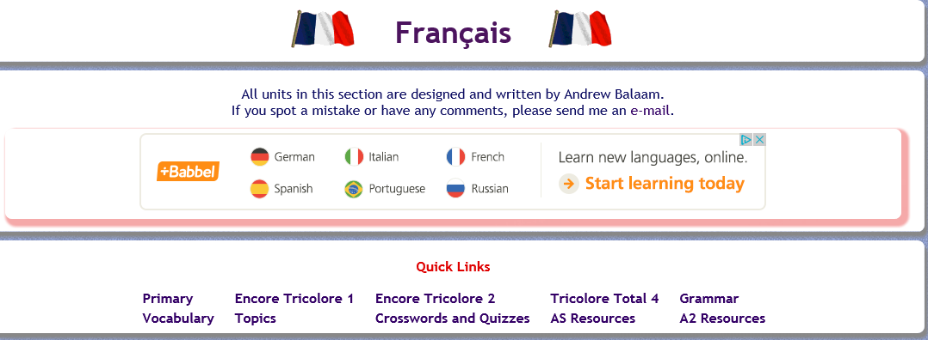
Either choose to practice your grammar or work through some of the AS Resources.

• Conjuguemos: a great website for practicing your verb conjugations. Find it here: https://conjuguemos.com/

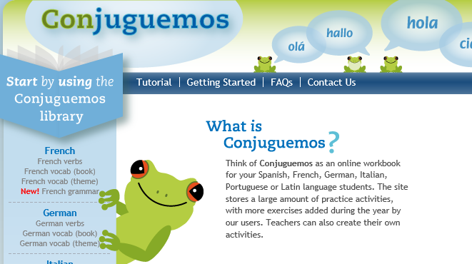
Click here to access the French verb exercises.

• Language skills: this website is free after 4pm and really comes into its own with its A level section. Practice your verbs, pronouns, do practice translations and review other grammar points. Find it here http://zut.languageskills.co.uk/advanced/year12.html.

Tasks
Complete the task log, or make your own one up but you will need to go through it with your French teacher in September so make sure that it is clear and useful to you.
When you look at a website/ link on here, highlight it and note the date and what you thought about it. You can then put a couple of notes in your task log.

1. Create a Memrise account – your name or something that is very recognisable as you. You should aim to achieve 100,000 points by the first lesson – prizes for those who achieve it!

2. Summarise, in French, 2 articles (that were in French!) that you have read from one of the websites/ papers above and say why they interested you. If you cannot print the article, make a note of the website. Try and make these related to one of the topics we will study (listed below).

▪ Changes in family structures, attitudes towards marriage, couples and the family.
▪ The education system and problems facing students today.
▪ Working life, attitudes to work, the right to strike and equality of the sexes.
▪ Changes in music and its impact on popular culture
▪ Freedom of expression in the media, written and online press and its impact on society and politics
▪ Festivals and traditions of France and francophone countries.

3. Translate the blurb for Entre les Murs before watching it. Bring this along with you on paper to your first lesson:

François Marin est un jeune professeur de français dans un collège difficile du 19e arrondissement de Paris. Il n'hésite pas à affronter Esmeralda, Souleymane, Khoumba et ses autres élèves, souvent impétueux, dans de stimulantes joutes verbales, faisant très souvent de la langue française un véritable enjeu. Mais l'apprentissage de la démocratie dans une salle de classe peut parfois comporter de vrais risques, et François, comme les collègues qu'il croise dans la salle des professeurs, se retrouve parfois débordé par des conflits ou des débats qu'il ne maîtrise plus. Les rencontres avec les parents se révèlent pleines de surprises, certains d'entre eux ne parlant pas français...

4. Choose a Francophone country and prepare a short presentation on an aspect of culture – this should last no longer than 5 mins. You can create a PPT if you want, but try and use headings rather than too much prose on the slide. This will be good practice for your IRP.

5. Look out for any items in the English or French media relating to topics we will study – as above so that you have points to make in a discussion and opinions to give.

6. Go onto www.languagesonline.org.uk . Complete 10 exercises. Each exercise takes less than 5 minutes. Note down the exercise you did and your score.

7. Complete the grammar review (Appendix 1) so that you can target any areas you feel weak on and feel good about the areas you know.

8. Complete the tense worksheet (Appendix 2) to practice your tenses.

9. Read through the AQA A-Level French course overview so that you have an idea of what we will be studying. This will also help you with task 4 above.

10. If you find any other websites/ links/ twitter feeds that you think are worth sharing, note them down too.

11. Each time you pass a second hand shop, pop in and see whether they have any large dictionaries or any French books – either fiction or grammar. You can find old French dictionaries worth £35 on sale for less than £5!

Task Log

Date | Website / source | Comments

Appendix 1: Grammar self-assessment

 |  | I DO NOT KNOW | NEED TO LEARN | QUITE CONFIDENT | FULLY  CONFIDENT
 | Nouns: gender, singular and plural forms
 | Articles: definite (le, la...), indefinite (un, une)
 | Partitive (de, du...)
 | Adjectives: agreements (fem, pl...)
 | Position/word order
 | comparative and superlative (plus, la plus..)
 | comparative and superlative irregular (mieux...)
 | demonstrative (ce, cet, cette, ces)
 | indefinite (chaque, quelque)
 | possessive (mon, ta...)
 | interrogative (quel, quelle...)
 | Adverbs: comparative and superlative
 | interrogative (comment, quand)
 | Quantifiers/intensifiers (très, assez...)
 | Pronouns: Subject (je, tu...)
 | object: direct and indirect (le, lui...)
 | position and order (je la lui donne)
 | reflexive (me, te...)
 | relative (qui, que,)
 | relative: lequel, auquel, dont (R)
 | object: direct and indirect
 | disjunctive/emphatic (moi...)
 | demonstrative (celui...) (R)
 | indefinite (quelqu’un)
 | possessive (le mien...) (R)
 | interrogative (qui, que)
 | interrogative (quoi) (R)
 | use of y, en (+ word order)
 | Verbs: modes of address (tu, vous)
 | impersonal verbs (pleuvoir...)
 | verbs + infinitive
 | verbs + infinitive + preposition
 | Verbs + à (je m’intéresse à)
 | Verbs + de (je viens de)
 | dependent infinitives (faire, laisser réparer) (R)
 | negatives (ne..plus, pas...)
 | Interrogative [question] forms (avez-vous...)
 | Present (regular)
 | Present (irregular)
 | Perfect with avoir
 | Perfect with être
 | Perfect with reflexives
 | Imperfect
 | Future

My notes/comments

 |  | DON’T KNOW | NEED TO LEARN | QUITE CONFIDENT | FULLY  CONFIDENT
 | Conditional
 | Future perfect (j’aurai fini...) (R)
 | Conditional perfect (je serais parti...) (R)
 | Pluperfect (j’avais eu...)
 | Past historic (j’eus...) (R)
 | Passive voice present (il est élu..) + others (R)
 | Imperative (vas-y)
 | Present participle (ayant...)
 | Subjunctive mood (how to form it)
 | Subjunctive mood (when to use it)
 | Indirect speech
 | Inversion after speech (R)
 | Prepositions: à, au...
 | with countries, towns, places
 | with month, dates, time
 | depuis, venir de
 | Number, quantity and time
 | Conjunctions

REFERENCES: Internet

My notes/comments

www.languagesonline.org.uk www.s-cool.co.uk/a-level/french http://french.about.com www.verb2verbe.com www.alevelfrench.com www.frenchexams.org www.lepointdufle.net www.bbc.co.uk/languages/french

Reference books

Élan grammar workbook
Easy learning French grammar Practice in French grammar
Help yourself to French grammar

(R) recognise only
general site with an A Level section & GCSE revision (grammar very good) good site with lots of materials & downloads (need to register but free)
a really good general site for grammar
site which translates any verb in any form (F>E & E>F) click on: move up to A Level transition
interactive revision materials
a very comprehensive search engine for French grammar interesting site especially the French slang section

Oxford Collins
Nelson Thomas Longman

Appendix 2: Tenses workout

Can you identify the tense (or mood)? Use the highlighted abbreviations & then translate in to English

1. J’ai dû y aller hier
2. Je voudrais aller au Maroc 3. Elle a de la chance
4. Elles avaient eu des problèmes avec la voiture 5. Il arriva chez lui à dix-huit heures
6. Il faut que je fasse un effort
7. Il arrivera en retard comme toujours 8. Il est parti en courrant
9. Allez-y!
____ ______________________________ ____ ______________________________ ____ ______________________________ ____ ______________________________ ____ ______________________________ ____ ______________________________ ____ ______________________________ ____ ______________________________
____ ______________________________

10. Il aura fini son travail demain 11. J’aurais voulu voir ce film
12. Je jouais au foot quand j’étais jeune
13. Il va regarder la télé ce soir
____ ______________________________ ____ ______________________________ ____ ______________________________
____ ______________________________

PResent IMPerfect PERFect (le passé composé) Conditional Past Conditional Future Future PERFect NEAR Future Past Historic (present) Subjunctive PLUperfect PResent PARTiciple IMPERative

Fill in the grid with both the je (first person) and il/elle/on (third person singular) forms

Infinitiv e | Present | Imperfect | Perfect | Future | conditional | Subjunctive
aller | _______ va | _________ | suis allé___ | ________ | __________ irait | _________
être | _______ | étais_____ | _________ | ________ | __________ | _________
avoir | _______ | _________ | _________ | ________ | __________ | _________
faire | _______ | _________ | _________ | ________ | __________ | _________
pouvoir | _______ | _________ | _________ | ________ | __________ | _________
savoir | _______ | _________ | _________ | ________ | __________ | _________
devoir | _______ | _________ | _________ | ________ | __________ | _________
prendre | _______ | _________ | _________ | ________ prendra | __________ | _________
venir | _______ | _________ | _________ | ________ | __________ | vienne____
partir | _______ part | _________ | _________ | ________ | __________ | _________

vouloir | _______ | _________ | _________ | ________ | __________ | _________
voir | _______ _ | _________ _ | _________ _ | ________ _ | __________ _ | _________ _

Fill in the blanks with the correct form of the infinitive

1. Si j’ (avoir PLU)______________________ le temps, j’y (aller PC)_________________________
2. En me (lever PR PART) _____________ ce matin je me (faire PERF) ____________________ mal
3. S’il (pleuvoir PR) _________________, je (rester F)_______________ chez moi
4. (s’asseoir IMPER)_________________ vous et (ouvrir IMPER) __________________ vos cahiers
5. Je (aller PC) __________________ en France mais il (faire IMP) __________________ trop froid 6. Il (falloir -PR) ________________ que je (faire S) ________________ mes devoirs ce soir
7. Je (faire C) ________________ le tour du monde si je (gagner IMP) _______________ au loto
8. Je (devoir PR) __________ finir ma rédaction car j’ (devoir PC) __________________ la rendre hier
9. Je (regarder IMP) _________________ la télé quand on a (sonner PERF)_____________ à la porte
10. Je ne (savoir F) _____________ jamais apprendre le chinois car c’(être PR)___________ trop difficile 11. Je (partir F PERF) ____________________________ dans deux heures
12. Il (sortir PERF) ______________________ en (courrir PR PART) ______________ car il (oublier PLU) __________________ qu’il (devoir IMP) __________________ travailler aujourd’hui
13. Je (regarder IMP)___________________ la télé quand mon copain (sonner PERF)_______________ 14. J’(devoir PC)_____________________ payer ma carte de crédit à temps
15. Il faut que tu (savoir S) ___________ que je (aller PR) ____________ arriver en retard mais j’ (vouloir CP) ___________________être à l’heure car je n’ (aimer PR)___________ pas me dépêcher
16. En (essayer PR PART)_______________ de perdre des kilos en plus, elle (se rendre PERF) __________ ____________________ très malade alors elle ne (faire PR) ___________ plus régime maintenant
17. S’il (conduire IMP)__________________ avec prudence il (avoir C)_____________ moins d’accidents 18. Nous (rester PC) _____________________________ plus longtemps
19. T’ (se taire IMPER) __________________ et (faire IMPER) ____________________ ton travail
20. Je n’ (comprendre PLU) __________ pas _____________ ce qu’il (dire IMP) ____________________

What I need to revise

______________________________________________________________________________________

______________________________________________________________________________________

