A-LEVEL GEOGRAPHY
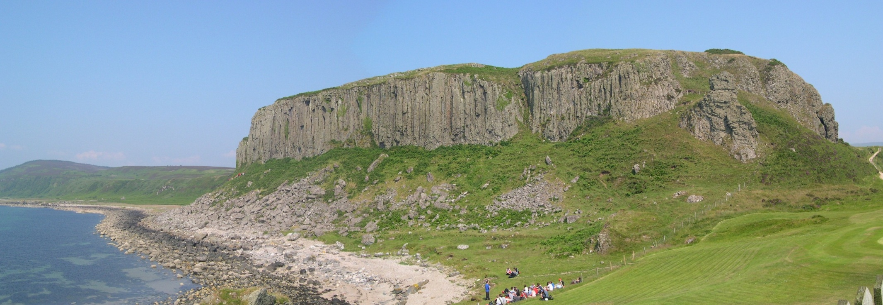

STUDENT GUIDE
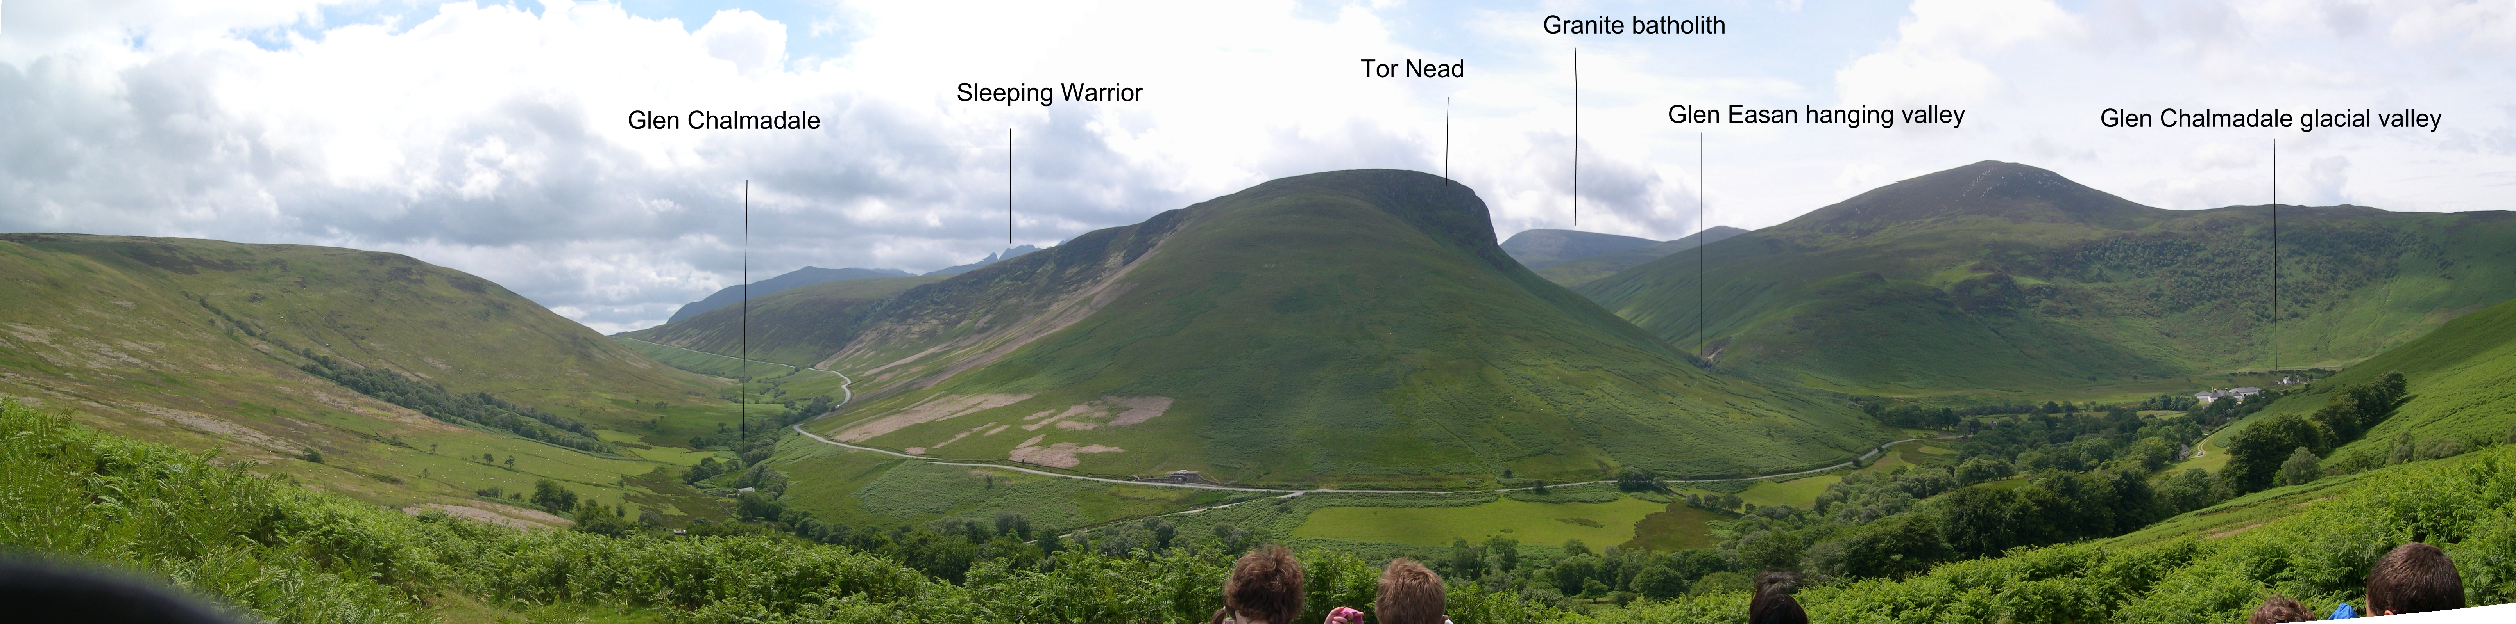

NAME: _______________________________

Name:
A-LEVEL GEOGRAPHY

My group meets on:

MONDAY (week A) from_____/_______ to _______/_______room____

TUESDAY (week A) from______/______ to _______/_______room____

WEDNESDAY (week A) from______/______ to _______/_______room___

THURSDAY (week A) from______/______ to _______/_______room___

FRIDAY (week A) from______/______ to _______/_______room___

MONDAY (week B) from_____/_______ to _______/_______room____

TUESDAY (week B) from______/______ to _______/_______room____

WEDNESDAY (week B) from______/______ to _______/_______room____

THURSDAY (week B) from______/______ to _______/_______room____

FRIDAY (week B) from______/______ to _______/_______room____

COMMAND WORDS LIST

Below is a list of the key words that are used in the examination. You should cut these pages from the booklet and stick it in the front of your exercise book. It will be used throughout your course.

COMMAND WORD | MEANING
- Identify..., What...?, Name..., Give....

- Define...., Explain the meaning of..., What is meant by......?, Outline......

- Describe...

- Describe the characteristics of.....

- Describe the changes in....

- Describe the differences between...

- Describe the relationship between...

- Describe the distribution of...

- Compare...

- Explain...., Suggest reasons for..., How might.....?, Why....?
- Using only an annotated diagram...., With the aid of a diagram...
- Analyse...
- Discuss...
- Discuss the extent to which...
- Discuss the varying/various attitudes to...
- Evaluate..., Assess...
- Justify...

WELCOME & INTRODUCTION

Welcome to ‘A’ Level Geography. Congratulations on passing your GCSE Geography. We hope you enjoy your ‘A’ Level and have continued success during this course.

Aim of the Guide
- To help in the transition from GCSE to ‘A’ Level Geography
- To introduce you to the Geography Department and your fellow students
- To give an outline of the course and the examination
- To strengthen and develop your study and employability skills
- To outline our expectations.

After the induction programme you will receive feedback indicating:

- Your current strengths in terms of study skills and employability skills

- The specific areas that you can improve in terms of study skills and employability skills

EXPECTATIONS

We have expectations of you as students just as you would have expectations of us as members of staff

The reason we have expectations are simply because WE WANT YOU TO BE SUCCESSFUL

These expectations include:

- 95% attendance as a minimum. This will give you a much better chance of being successful.

- Being punctual to all lessons. The timetable is structured in such a way that you have breaks in between lessons and there is no excuse for being late to lessons. The teachers and students on time will not wait to start the lesson for those who are late.

- Being ready to learn. You should have the following equipment to show us every lesson:

- Exercise book/folder
- Assessment book/folder
- Paper & Pens (for every lesson)
- Calculator, compass, protractor, ruler

- Being respectful at all times to peers, staff and the environment

- Contact details - Keep the school informed of all contact details – your mobile and email, your parents mobile and email and any change of address
- Wearing your lanyard when on school premises – WHY IS THIS IMPORTANT?

THE GEOGRAPHY STAFF

Mr BARTLETT BSc. Geography Open University
Member of the Geographical Association
Enthusiast of the importance of Geography in the wider world. Member of the Green Party.

Mr FISHER BSc. Geography University of Wales – Swansea
PGCE Keele University
First teaching post was at Palmer’s College.

LOCATION Geography is taught in VARIOUS rooms.

IF YOU HAVE ANY QUESTIONS COME AND SEE US

Watch the you Tube video clips on “Going Places with Geography” and note down the different careers that geography students have moved into:

HOW CAN GEOGRAPHY HELP ME IN MY DREAM JOB?

Discuss in pairs and then think about your dream job and complete the details below:

Job: ……………………………………………………………………….

Employability skills needed to do the job well

1.

2.

3.

4.

5.
Pick one of these skills and be prepared to explain why you think it is important to this job.

At St Bernard’s we devote a lot of time into developing your employability skills because we want you to eventually get your dream job. The kind of things you can expect include:

- Tasks in lesson which develop specific skills e.g. communication, team-work, note making, presentation skills
- Careers events
- Guest speakers
- Trips/visits

Discuss how studying Geography might help you with AT LEAST ONE of the five employability skills and note down below:

Growth mind-set and resilience

Watch the video and be ready to discuss the following:

https://www.youtube.com/watch?v=zLYECIjmnQs

What characteristics are demonstrated in the people named in these videos?

Characteristics | Explanation

Now record your definition of these two important terms.

Growth Mindset
Resilience

COURSE CONTENT 1.

EXAMINING BODY IS AQA SYLLABUS CODE 7037
‘A’ LEVEL GEOGRAPHY CONSISTS OF THREE PARTS:

- PHYSICAL GEOGRAPHY

- HUMAN GEOGRAPHY

- GEOGRAPHICAL INVESTIGATION

Together these make up the whole A-level examination on the following proportions:

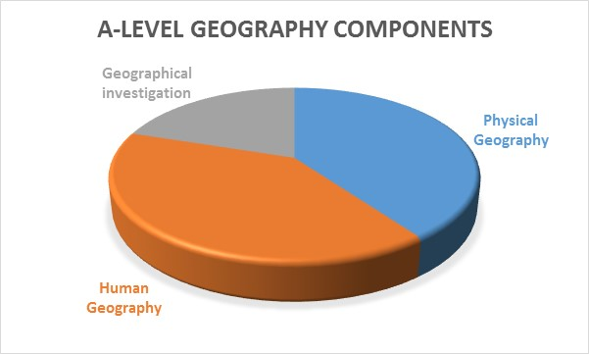

COURSE CONTENT 2

A-LEVEL

The A- Level studied has the following three components:

component 1: Physical Geography

PHYSICAL GEOGRAPHY
- Core unit on water and carbon cycles

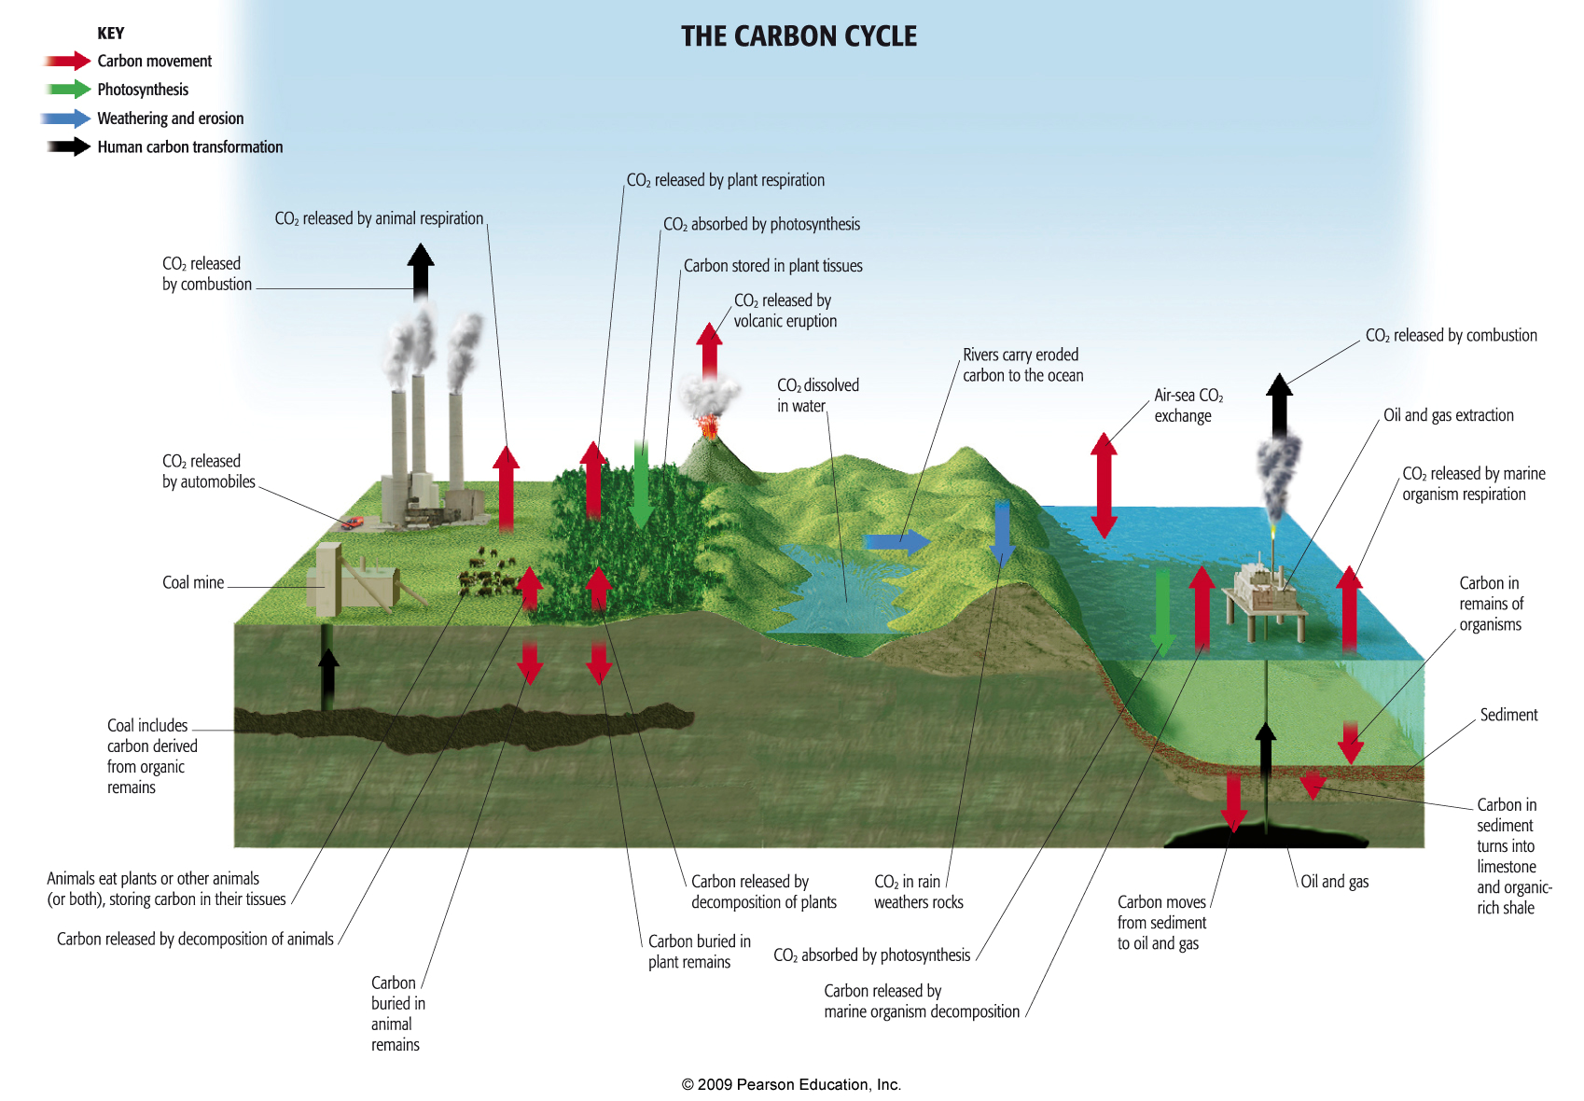
Carbon and water cycles as natural systems. The water cycle. The carbon cycle. Water, carbon and climate. case studies of a tropical rainforest and river catchment at a local scale.
- Optional unit on coastal systems and landscapes

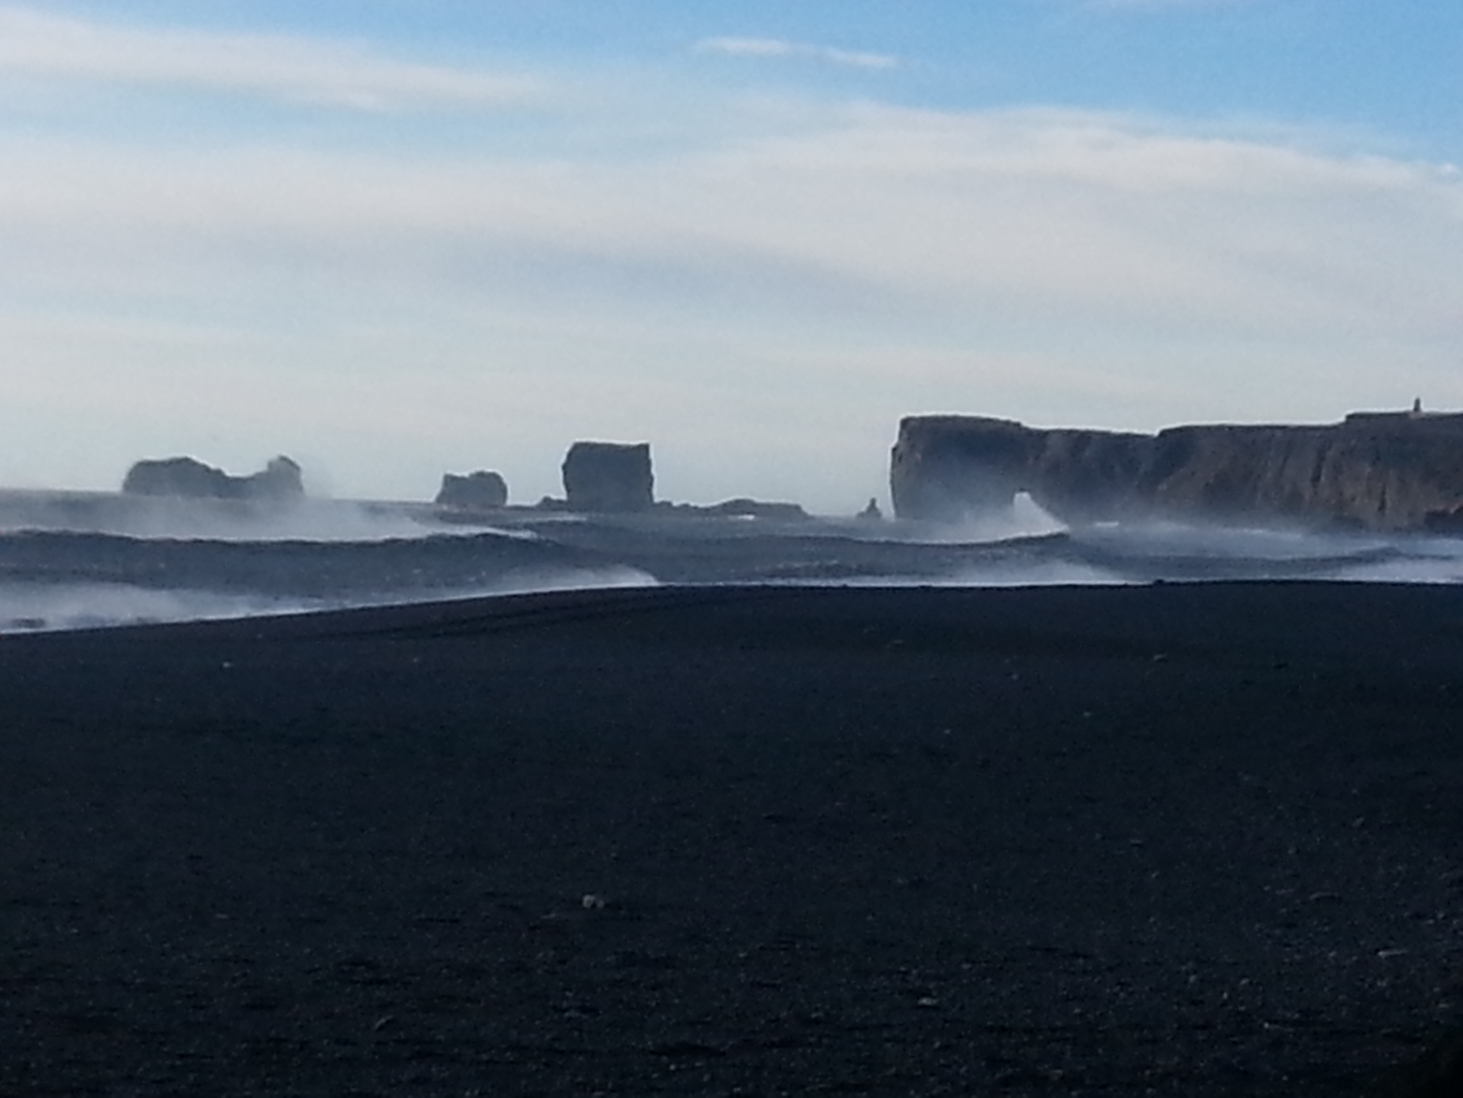
Coasts as natural systems. Systems and processes. Coastal landscape development. Coastal management. Case studies of coastal areas at a local scale and abroad to study the above.

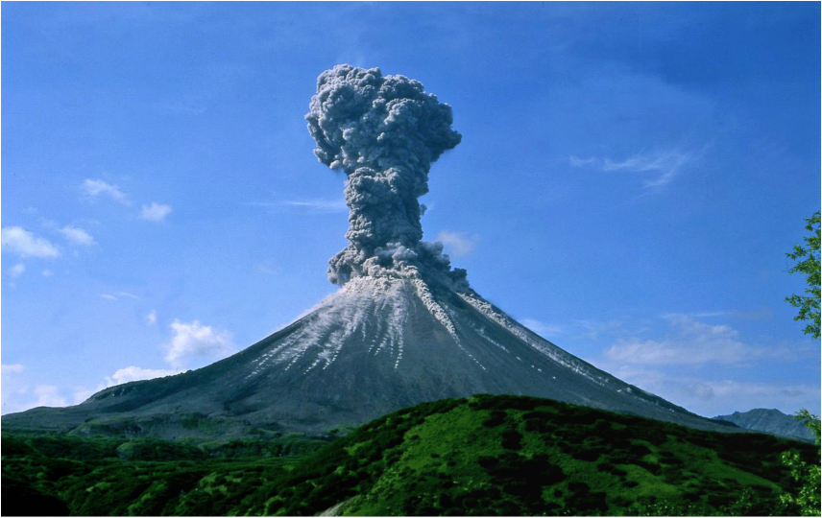
- Optional unit on Hazards
The concept of a hazard. Volcanic, seismic and storm hazards : their nature, impact and responses.
Two case studies: one of a foreign hazardous environment and one of a local area.

component 2: Human Geography

HUMAN GEOGRAPHY
- Core unit on global systems and global governance

International trade and access to markets: globalisation, forms and patterns of international trade, impacts of globalisation.
Global governance: responses to globalisation, the “global commons”, threats to Antarctica, protection of Antarctica.

- Core unit on changing places
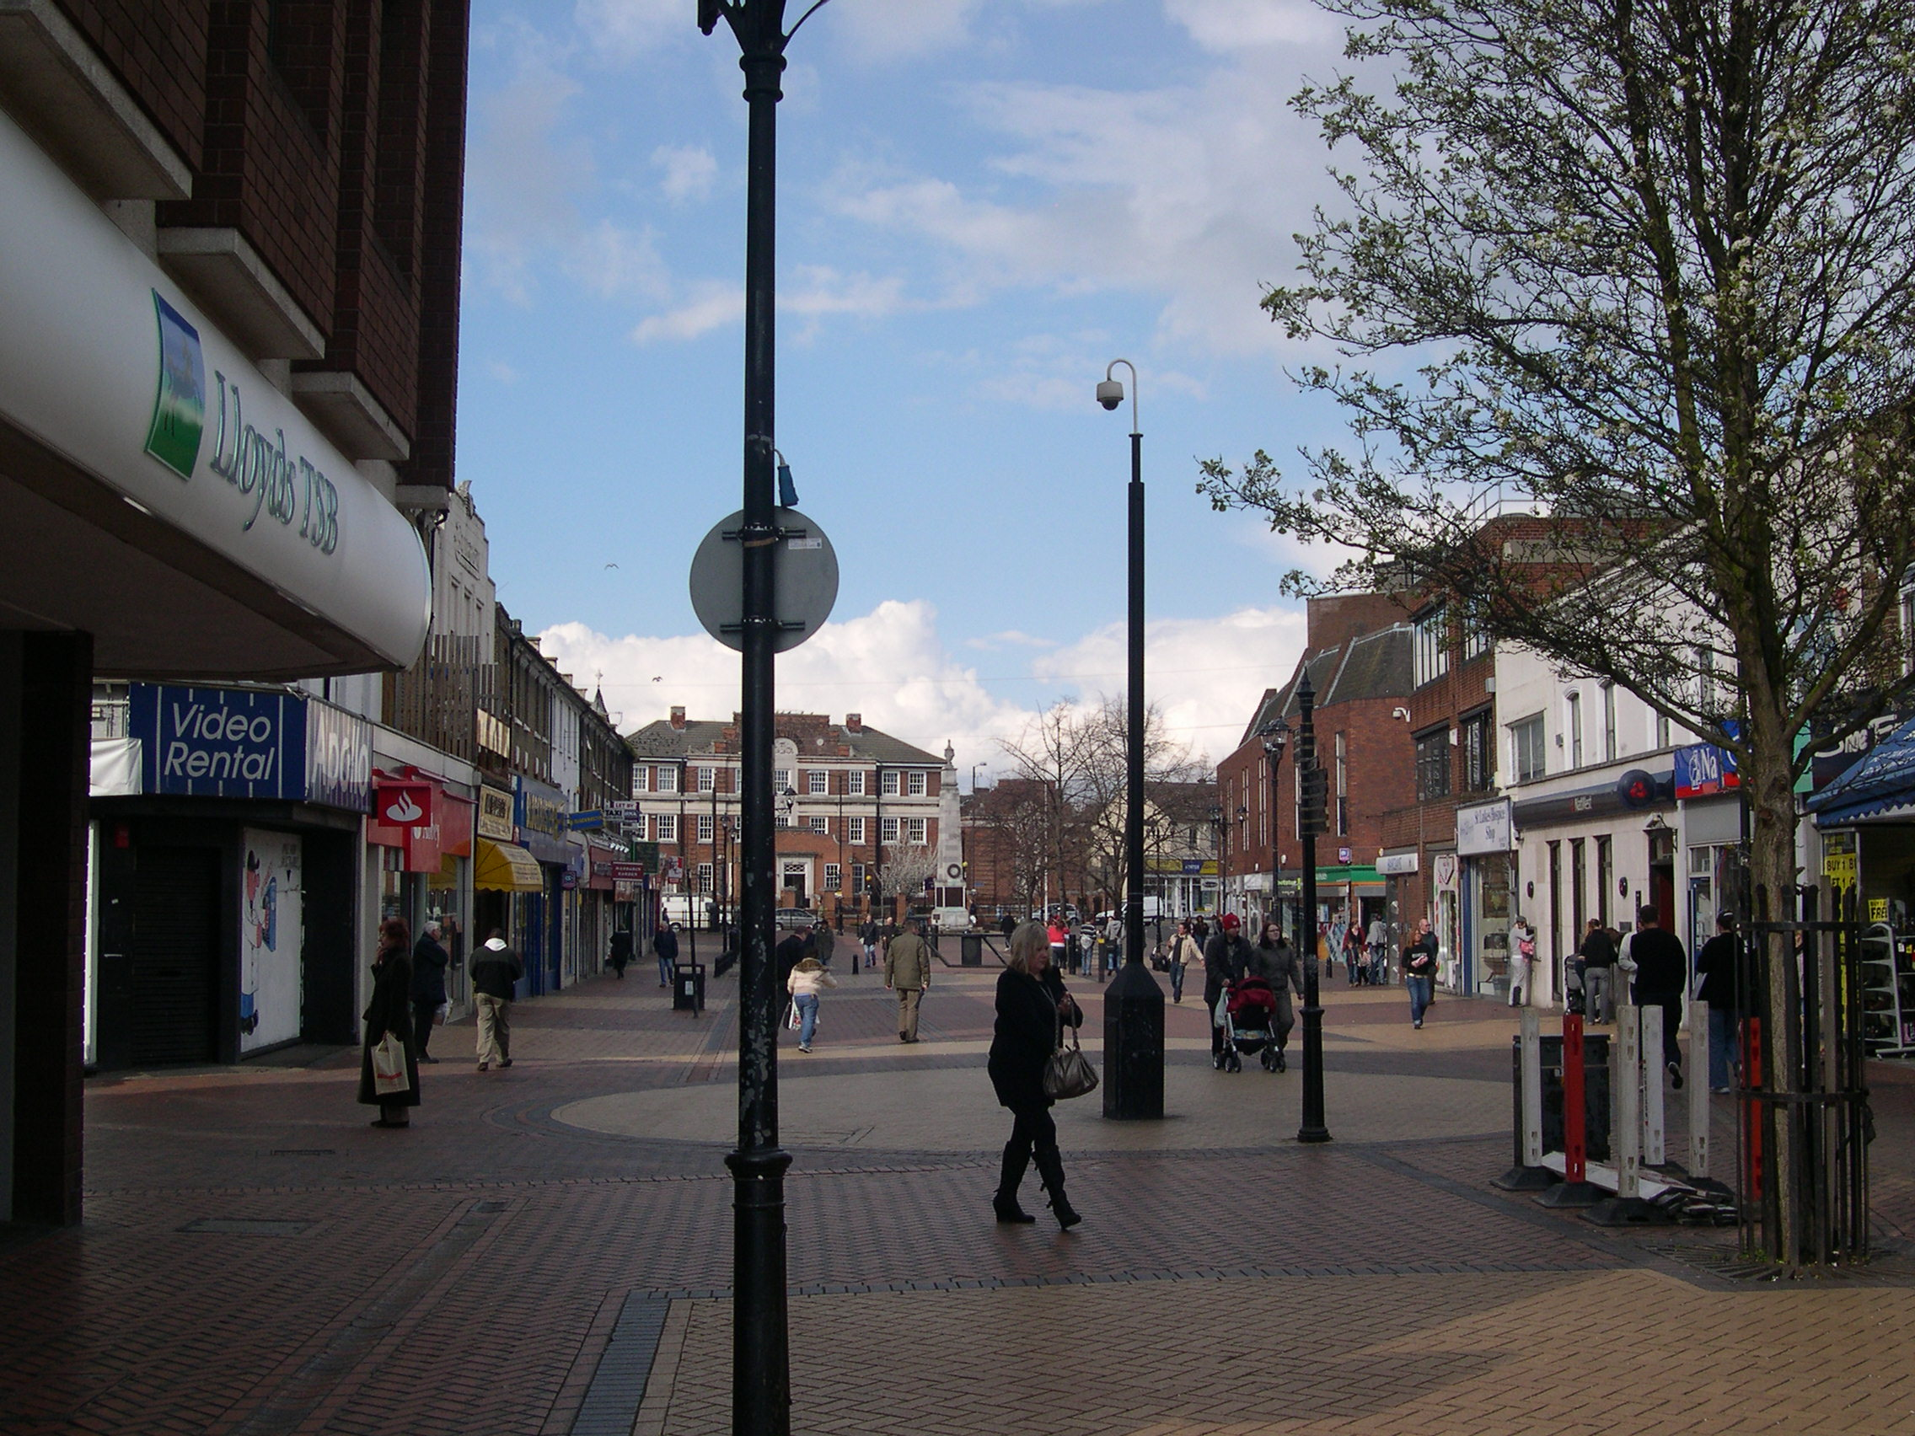
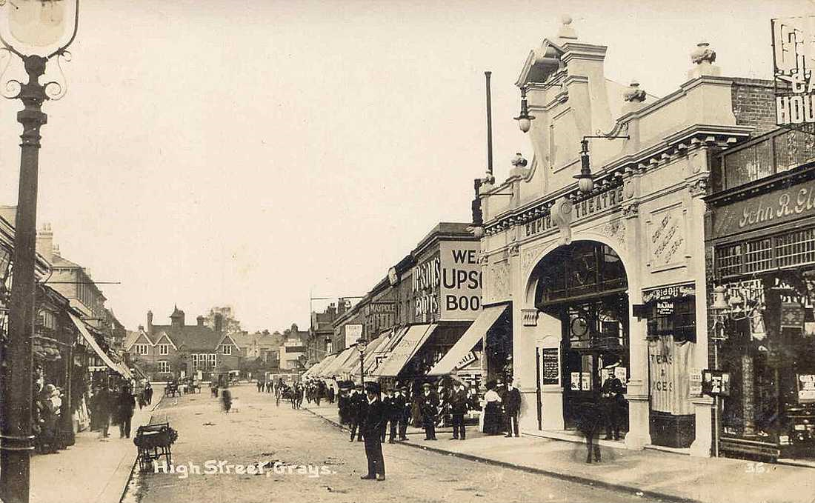
Grays High Street today Grays High Street in the 1920s

The nature and importance of places. knowing and understanding places. the dynamics of changing places. place studies: exploring the developing character of a local area and a contrasting place.

- Optional unit on contemporary urban environments

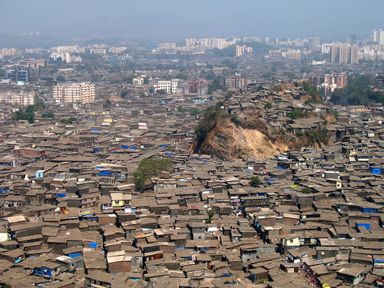
Urbanisation. Urban forms, social and economic issues associated with urbanisation. Urban climate. Urban drainage. urban environmental issues (air pollution, water pollution, dereliction and waste disposal). Sustainable urban growth. Case studies: Two contrasting urban areas to study the above.
component 3: Geographical investigation

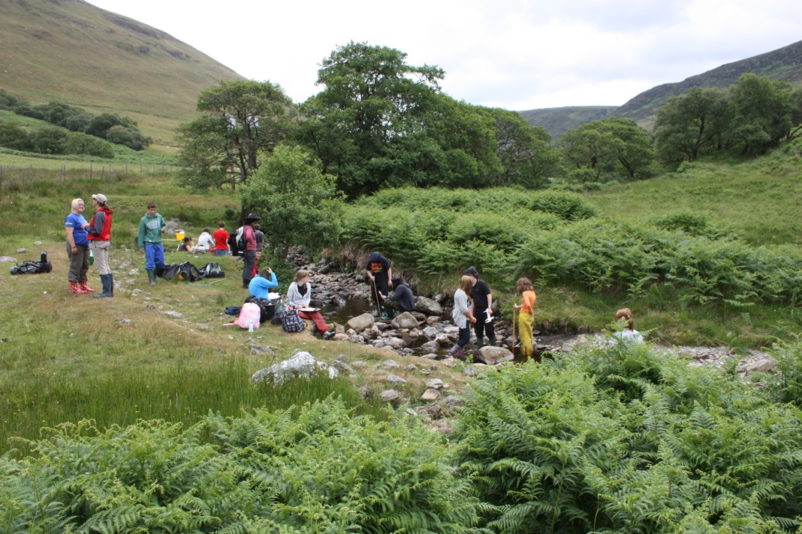
Physical and human geography fieldwork over four days. Investigation of a question or issue on any part of the syllabus. It must include primary data collection, be written up and submitted for assessment. it should be between 3000-4,000 words. It will be assessed by your teacher and moderated by the exam board.

ASSESSMENT OF A- LEVEL

This will be taken in June 2021 at the end of the course. It consists of two examinations:

EXAMINATION NUMBER 7037

PAPER 1 PHYSICAL GEOGRAPHY 2 HOURS 30 minutes

120 marks
40% of the A-level

Multiple choice, short answer, levels of response and extended prose (essay).
SECTION A

- Compulsory question on Water and carbon cycles (multiple choice, short answer and levels of response). (36 marks)

SECTION B

- Question on Coastal systems and landscapes (multiple choice, short answer and levels of response). (36 marks)

SECTION C

- Question on Hazards (short answer, levels of response and extended prose – essay. (48 marks)

Total marks for this paper = 120

PAPER 2 HUMAN GEOGRAPHY 2 HOURS 30 minutes

120 marks
40% of the A-level

Multiple choice, short answer, levels of response and extended prose (essay).

SECTION A

- Compulsory question on global systems and global governance (multiple choice, short answer and levels of response). (36marks)

SECTION B

- Compulsory question on Changing Places (multiple choice, short answer and levels of response). (36 marks)

SECTION C

- Question on Contemporary urban environments (short answer, levels of response and extended prose – essay. (48 marks)

Total marks for this paper = 120

PAPER 3 GEOGRAPHICAL INVESTIGATION

60 marks
20% of the A-level

A 3,000-4,000 word independent investigation that must:

  - be based on a question or issue defined and developed by the student individually to address aims, questions and/or hypotheses relating to any part of the specification content
  - incorporate field data and/or evidence from field investigations
  - draw on the student's own research and/or secondary data
  - require the student to independently contextualise, analyse and draw conclusions
  - involve presentation and analysis of data and findings, and extended writing.

Total marks for this paper = 60

A-LEVEL GEOGRAPHY SKILLS CHECKLIST

SKILLS |  | Covered  (ü) | Where done in course
QUALITATIVE DATA | - Use and understand interviews/questionnaires
 | - Interpret and evaluate text and visual sources
 | - Understand the advantages and disadvantages of coding and sampling and how they can influence outcomes.
 | - Understand the ethical and socio-political implications of collecting and using geographical data about human communities.
QUANTITATIVE DATA | - Understand what makes data geographical and how technology can collect, analyse and present it (GIS)
 | - Collect and use digital and geo-located data.
 | - Central tendency and dispersion
 | - Measures of difference and association, inferential statistics and relational statistics
 | - Measurement, measurement errors and sampling.
CORE SKILLS | - Use and annotation of illustrative and visual material: base maps, sketch maps, OS maps (at a  variety of scales), diagrams, graphs, field sketches, photographs, geospatial, geo-located and  digital imagery.
 | - Use of overlays, both physical and electronic.
- Literacy – use of factual text and discursive/creative material and coding techniques when
analysing text.
 | - Numeracy – use of number, measure and measurement.
 | - Questionnaire and interview techniques.
CARTOGRAPHIC SKILLLS | - Atlas maps.
 | - Weather maps – including synoptic charts.
 | - Maps with located proportional symbols.
 | - Maps showing movement – flow lines, desire lines and trip lines.
 | - Maps showing spatial patterns – choropleth, isoline and dot maps.
GRAPHICAL SKILLS | - Line graphs – simple, comparative, compound and divergent.
 | - Bar graphs – simple, comparative, compound and divergent.
 | - Scatter graphs, and the use of best fit line.
 | - Pie charts and proportional divided circles.
 | - Triangular graphs.
 | - Graphs with logarithmic scales.
 | - Dispersion diagrams.
STATISTICAL SKILLS | - Measures of central tendency – mean, mode, median.
 | - Measures of dispersion – range, inter-quartile range and standard deviation.
 | - Inferential and relational statistical techniques to include Spearman’s rank correlation and Chisquare
ICT SKILLS | - Use of remotely sensed data (as described above in Core skills).
 | - Use of electronic databases.
 | - Use of innovative sources of data such as crowd sourcing and ‘big data’.
 | - Use of ICT to generate evidence of many of the skills provided above such as producing maps,

GEOGRAPHY A-LEVEL

In geography we do a lot of team-work, especially for your projects. Also there will be group work in class. Therefore you need to get to know each other as you will also all be from different schools both from within and outside of Thurrock. This task is designed to help you find out about each other and especially about geography.

SHARE/SHARE TRADE

- On the mini whiteboard write down:

- Your name;
- Your previous school;
- Reasons why you want to do A level Geography;
- Other subjects studying;
- Three interesting facts about yourself (could be anything!);

- Now spend a couple of minutes sharing this information with your neighbour.

- Your neighbour should then do the same.

- Swap your mini whiteboard with your neighbour and repeat previous steps with someone else in the class.

- Continue until you are told to stop. YOU CANNOT TALK TO THE SAME PERSON TWICE!
- At the end be prepared to talk about the person whose whiteboard you are left with to the rest of the class.
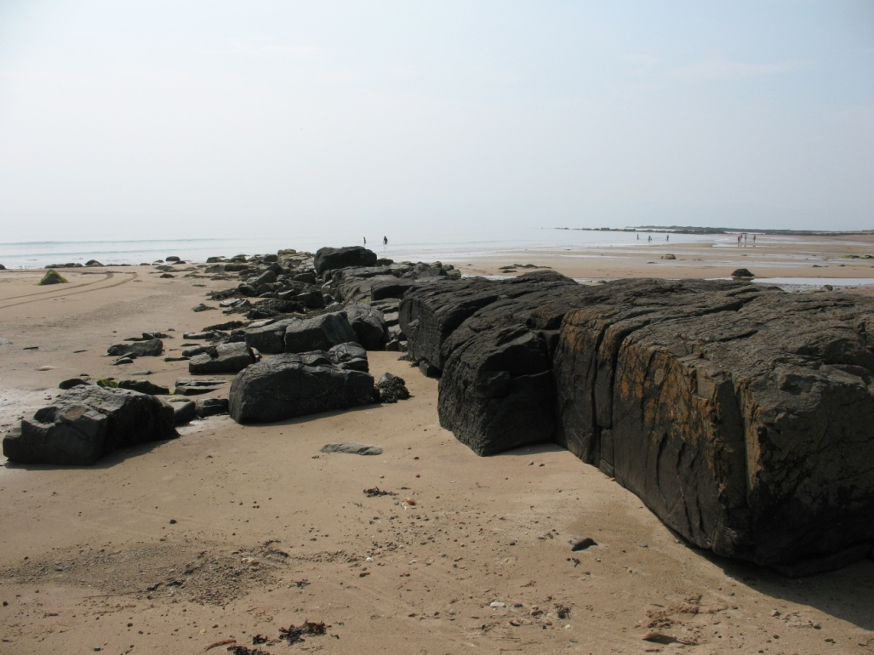

Questions for discussion:

- What is the name of your exam board and syllabus number?

- How is the content of component 3 different to components 1 and 2?

- What are the CORE units on components 1 and 2?

- What are the OPTIONAL units we will study on components 1 and 2?

- What are the total number of questions on your two exam papers?

- Is it true you can do your personal investigation on any topic you like?

- Name the seven different types of geographical skills covered in your course.

- What are the FIRST and LAST physical topics studied over the two years?

- What are the FIRST and LAST human topics studies over the two years?

- What are the case studies needed for each of the six topics studies at A level?

- When will you write up your personal investigation? When will it be submitted?

TEACHING PROGRAMME & KEY DATES
A-LEVEL 2020-2021

YEAR 1 2 2020-21

TIME | CONTENT
AUTUMN TERM | HAZARDS
FORMAL ASSESSMENTS  (2 per half term) | An examination question based on the above unit. This will contribute towards your target grade and be recorded on GO4Schools and used for report and predicted grades
SPRING TERM | CONTEMPORARY URBAN ENVIRONMENTS
FORMAL ASSESSMENTS  (2 per half term) | An examination question based on the above unit. This will contribute towards your target grade and be recorded on GO4Schools and used for report and predicted grades
SUMMER TERM | COASTAL SYSTEMS AND LANDSCAPES
FORMAL ASSESSMENTS  INTERNAL MOCK EXAMINATIONS | An examination based on the topics covered throughout the year. This will form the basis of your end-of-year report and will be used to assess your progress from the start point at the beginning of the year. It will also form the basis of your predicted grade for university applications.
FOUR DAYS FIELDWORK, PROBABLY IN ARRAN, SCOTLAND TO ENABLE YOU TO COMPLETE THE GEOGRAPHICAL INVESTIGATION WORTH 20% OF YOUR FINAL GRADE.

YEAR 13 2 021-2022

TIME | CONTENT
AUTUMN TERM | GLOBAL SYSTEMS AND GOVERNANCE
FORMAL ASSESSMENTS  (2 per half term) | An examination question based on the above unit. This will contribute towards your target grade and be recorded on E tracker and used for report and predicted grades | Geographical investigation write up and submission by Christmas to the examination board for moderation
SPRING TERM | WATER AND CARBON CYCLES
FORMAL ASSESSMENTS  (2 per half term) | An examination question based on the above unit. This will contribute towards your target grade and be recorded on GO4Schools and used for report and predicted grades
SUMMER TERM | CHANGING PLACES
FORMAL ASSESSMENTS  (2 first half term) | An examination question based on the above unit. This will contribute towards your target grade and be recorded on GO4Schools and used for report and predicted grades
FINAL EXAMINATIONS | Paper 1 : Physical Geography  2 hours and 30 minutes  Paper 2 : Human Geography  2 hours and 30 minutes

Examination Dates (TO BE CONFIRMED):

