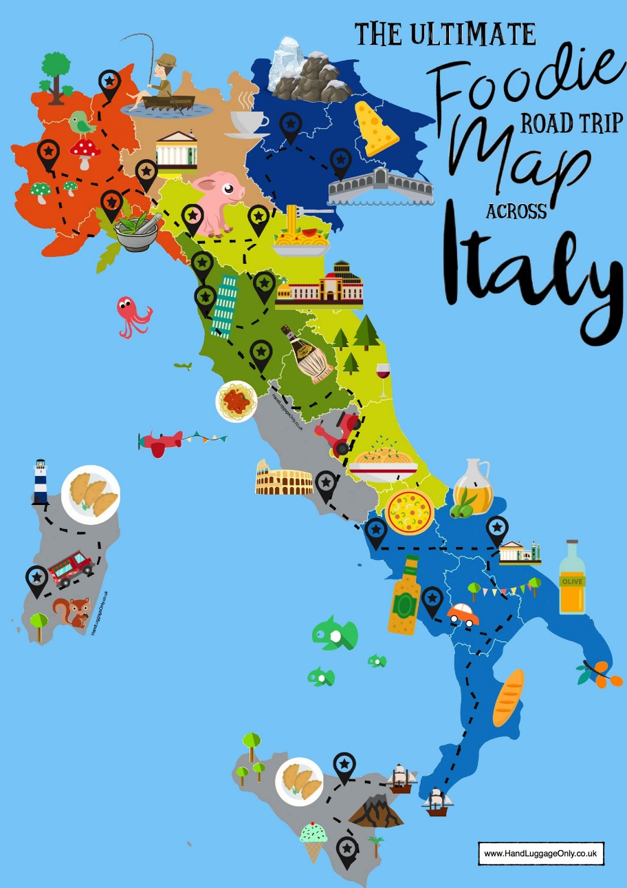

FIRENZE

ROMA

NAPOLI
La transizione dal GCSE all’A Level per italiano.

How to prepare for Italian at A Level
You have a few weeks in which to really prepare for your A Level in Italian. The leap from GCSE to A Level is significant. This booklet contains links to a huge range of media, most of which is available for free online as well as tasks to complete before the start of term. In order to keep pace, it is vital that you work through the tasks. Little and often…

Watch…

The news. Click on www.rai.it and then click on articles and/or video clips to keep up with news, sport, culture, etcetera.

Are you interested in cooking? Check out this site: www.giallozafferano.it and try out some delicious recipes. Buon appetito!

Are you interested in fashion/beauty? Check out these websites: www.grazia.it , www.marieclaire.it

MOVIES
Choose one (or more) of the following movies to watch over the summer:
- I cento passi (Marco Tullio Giordana, 2000)
- Il Postino (Michael Radford, 1994)
- La Grande bellezza (Paolo Sorrentino, 2013)
- La Vita è bella (Roberto Benigni, 1997)
- Nuovo cinema Paradiso (Giuseppe Tornatore, 1988)
- Va’ dove ti porta il cuore, (Cristina Comencini, 1996)

Read…
Keep your own vocabulary book for new expressions you come across. You could order it alphabetically, by topic area based on what we are going to study or just use it as a diary and scribble away your Italian development in it.

NEWSPAPERS AND MAGAZINES
Italian newspapers: www.repubblica.it www.corriere.it

Italian magazines: www.panorama.it www.famigliacristiana.it (Catholic - family magazine)

You do not have to read the paper cover to cover, just scan the headlines and pick out ONE article that grabs your attention.

Websites
Switch to Italian browsers such as www.yahoo.it and www.google.it
In this way, you will read in Italian every time you log on and it will become part of your everyday activity.

Go to www.gente.it or www.sorrisiecanzoni.it for an Italian celebrity gossip magazine (note that some content requires subscription). This also has short clips in Italian.

Go to www.lagazzetta.it if you are interested in sport.

Go to www.sorrisi.it if you are interested in TV, cinema, celebrities, fashion, gossip.

Go to www.casabella.it if you are interested in home decorating/home fashion

Go to www.donnamoderna.it if you want to read a magazine about modern young women‘s issues ; including fashion, make-up, everyday life, cooking, home, politics, etcetera.

Websites for research
Once you actually start your A Level in September, you will realise that you are almost completing a Sociology A Level in Italian. It is fascinating and you will learn all about the history and culture of Italian speakers across the world, not just in Italy.

If you are searching for information, try switching to the Italian version of Wikipedia. Remember that anyone can write on Wikipedia so you
must validate your research elsewhere and never quote from it! It is a good place to start though. it.wikipedia.org

British Council support available from http://schoolsonline.britishcouncil.org/

On-line dictionary
Try different sites, perhaps start with collinsdictionary.com

TIP When you look up a verb, click the Conjugation tab to see how the verb is conjugated in EVERY tense.

TOP TIP: Don’t look up every word you are not sure of when reading an article/ book

Yes… you read that right. When you are reading articles etc, try not to look up every word as it will take you forever. Skim and scan the text to get the gist. Remember to use the context or the article, cognates and common sense to figure out what the article is saying. Pick out a couple of words that you like the look of, that you feel may be real hurdles to getting the idea of the text, look them up carefully and add them to your vocab booklet. The aim at this stage is to get the gist of the article, not be able to translate it completely. Translation is a whole different ball game and you will learn it soon enough.

You will be surprised how much more enjoyable reading will be if you really pay attention to this tip.

What should I know by now?

This is a common question asked by students about to start their A level. You should be able to:

TOPIC | CONTENT
Recognise and use a range of tenses with regular verbs. | Regular –ARE, -ERE and -IRE verbs:  Tenses: Present  Preterite  Imperfect  NearFuture(ho intenzione di + infinito)  Future (eg. Sará)  Conditional (eg. sarebbe)
Recognise and use a range of tenses with irregular verbs. | Common irregular verbs: essere, avere, andare, fare, volere, dovere,sapere, potere.  Tenses: Present  Preterite  Imperfect  NearFuture(ho intenzione di + infinito) Future (eg. Sará)  Conditional (eg. sería)
Give opinions with reasons | • A range of opinion expressions  • Positive and negative reasons for opinions  • To be able to agree and disagree

Links to Grammar Practice Exercises •
- Languages on line: The Grammar Revision resources on
www.languagesonline.org.uk are great as you can then select what tense you want to revise, read the explanations and complete the exercises. You can do these as often as you like and it gives you a percentage. Another useful tactic is to translate the examples and exercises into English to ensure you understand the meaning of each tense.h some of the AS Resources.
• Conjuguemos: a great website for practicing your verb conjugations. Find it here: https://conjuguemos.com/k here to access the Spanish verb exercises.

Tasks (some ideas – optional)
Complete the task log, or make your own one up but you will need to go through it with your Spanish teacher in September so make sure that it is clear and useful to you.
When you look at a website/ link on here, highlight it and note the date and what you thought about it. You can then put a couple of notes in your task log.

- Create a Memrise account – your name or something that is very recognisable as you. You should aim to achieve 100,000 points by the first lesson – prizes for those who achieve it! You could start by doing the Italian course ).
- Download an app such as Duolingo and go back to it for 5 minutes every day if you can.

- Go on Giallo zafferano and cook an Italian recipe.
- Watch an Italian series/film/programme
- Get to know some Italian singers: Eros Ramazzotti, Laura Pausini, Mica, … Explore the Italian music and in particular the type of music you enjoy. Then find a singer you like and watch videos, read the lyrics and try and translate them. Watch a concert on YouTube.it

6. Go onto www.languagesonline.org.uk . Complete 10 exercises. Each exercise takes less than 5 minutes. Note down the exercise you did and your score.

7. Read through the Edexcel A-Level Italian course overview so that you have an idea of what we will be studying.

8. Each time you pass a charity shop, pop in and see whether they have any large dictionaries or any Italian books – either fiction or grammar. You can find old Italian dictionaries worth £35 on sale for less than £5!

9. Most of all……
ENJOY!!!! DIVERTITEVI!

HAVE FUN WITH ITALIAN!

PROF . VENNERO
Task Log (optional)

Date | Website / source | Comments

