A Level PE

St Bernard’s High School

Transition Work – Booklet

NAME:

Hi there,

I am delighted that you are thinking of studying A level Physical Education in September. The step up from GCSE work to A level can be tough and many students must adjust to the increased demands of workload, independence and responsibility. At the same time, students get the opportunity to study the subjects that they have been most interested in or are now shaping their pathway into University or apprenticeships. In order to give yourself the best start in Autumn with your new course, we suggest that you complete the following preparation tasks to the best of your ability. You may work through the booklet in any order you wish but I would encourage you to finish a section before you move onto another. Do what you can and feel free to contact the relevant teacher should you need some assistance.

Before you start the preparation tasks . . . perhaps you might like to know a bit about A level PE at St Bernard’s High School:

**The Course**

At our Sixth Form we follow the OCR course. The course is suited to students who have a genuine interest in sporting excellence and the science behind it. The two-year course covers 7 theoretical units per year and 1 personal sporting performance. Units include Anatomy and Physiology, Exercise Physiology, Biomechanics, Sports Psychology, and Skill Acquisition.

The course is 70% theory and 30% practical over the two years. The course is demanding both practically and theoretically therefore students must be competitively taking part in a sport/activity outside of sixth form.

**Non examined assessment. (Your practical assessment and coursework)**

The non-examined assessment makes up 30% of the course. Students will need to be assessed in one practical sport and will be required to collect video evidence during the two-year course. Students can be assessed as a player or coach in any of the following practical activities:

Handball

Hockey

Hurling

Kayaking

Lacrosse

Netball

Rock Climbing

Rowing

Rugby League

Rugby Union

Sculling

Skiing/Snowboarding (Must be competitive)

Squash

Tennis

Trampolining

Volleyball

Wheelchair Basketball & Rugby

Association Football

Amateur Boxing

Athletics

Badminton

Basketball

Blind Cricket

Boccia

Camogie

Canoeing

Cricket

Cycling (Track or Road)

Dance

Diving

Equestrian

Gaelic Football

Goal Ball

Golf

Gymnastics

Here is a link to the specification for the non-examined assessment, should you wish to look into this further: <https://www.ocr.org.uk/Images/234840-guide-to-non-exam-assessment-as-and-a-level.pdf>

**Help and advice:**

If you would like to speak to a member of the Physical Education department with any questions or queries that you may have please contact the following:

**Leader of A level PE:**

Contact email:

[aew@stbernards.southend.sch.uk](mailto:aew@stbernards.southend.sch.uk) – Sports psychology / Skill Acquisition

[rle@stbernards.southend.sch.uk](mailto:rle@stbernards.southend.sch.uk) – Sport and society / Contemporary Issues in physical activity and sport

[lbe@stbernards.southend.sch.uk](mailto:lbe@stbernards.southend.sch.uk) - Biomechanics

[crw@stbernards.southend.sch.uk](mailto:crw@stbernards.southend.sch.uk) – Anatomy and Physiology

[tac@stbernards.southend.sch.uk](mailto:tac@stbernards.southend.sch.uk) – Exercise Physiology

**Head of Department:**  tac@stbernards.southend.sch.uk

**Exercise Physiology**

1. Diet and Nutrition and impact on physical activity and performance

Complete a diary of your food and drink intake for two weeks. Make sure as much as possible you include a measurement (grams) so you can analyse your diet easier as part of the next task. If you prefer you can use an app to help with this (myfitnesspal). The more detail you provide the easier it will be to analyse the data.

*(I am not looking to catch anyone out to say how good or bad your diet is, this is purely an exercise to show you can calorie count, break food groups down and analyse your own data).*

|  |  |  |  |  |  |  |  |
| --- | --- | --- | --- | --- | --- | --- | --- |
| **Week 1** | **Monday** | **Tuesday** | **Wednesday** | **Thursday** | **Friday** | **Saturday** | **Sunday** |
| **Breakfast** |  |  |  |  |  |  |  |
| **Calories** |  |  |  |  |  |  |  |
| **Lunch** |  |  |  |  |  |  |  |
| **Calories** |  |  |  |  |  |  |  |
| **Dinner** |  |  |  |  |  |  |  |
| **Calories** |  |  |  |  |  |  |  |
| **Total** |  |  |  |  |  |  |  |

Work out how much protein, fat, carbohydrates for every day as well as your fluid intake

|  |  |  |  |  |  |  |  |
| --- | --- | --- | --- | --- | --- | --- | --- |
| **Week 1** | **Monday** | **Tuesday** | **Wednesday** | **Thursday** | **Friday** | **Saturday** | **Sunday** |
| **Fat (saturated/unsaturated)** |  |  |  |  |  |  |  |
| **Carbohydrates** |  |  |  |  |  |  |  |
| **Protein** |  |  |  |  |  |  |  |
| **Fluid intake** |  |  |  |  |  |  |  |

Show the data for each task in graph format (of your choice). Make sure your graphs are labelled clearly and you have provided a brief description of what each graph is showing. We will be using this information further in lessons.

**Question**

What is the recommended daily intake of calories for men and women?

What is a balanced diet? Why is it important we have a balanced diet?

**Exercise Physiology**

1. Preparation and training methods

In GCSE we looked at training methods.

What do the following mean?

FITT

MOT

MR SPOV

In conjunction with diet and nutrition I would like for you to log your exercise regime over a two-week period. Use FITT to assist with breaking your training down (like your PEP in GCSE PE). Provide as much detail as possible *(I do not need to know every exercise (keep a rough log if you wish) but you could say what type of session it was i.e. muscular endurance / strength and conditioning, cardio vascular etc).* Keep a log where possible of calories burned.

|  |  |  |  |  |  |  |  |
| --- | --- | --- | --- | --- | --- | --- | --- |
| Week 1 | Monday | Tuesday | Wednesday | Thursday | Friday | Saturday | Sunday |
| Calories burned |  |  |  |  |  |  |  |
| Type of session |  |  |  |  |  |  |  |
| Length of session |  |  |  |  |  |  |  |
| etc |  |  |  |  |  |  |  |

Show the information in graph format for week 1 and week 2. Describe what each graph is showing.

Compare week 1 and week 2. What did you find, what are the differences? Why is this?

We will be using this information further in lessons.

**Sports History and Sociocultural Issues**

The Origins of Football Teams

Research where the following football teams originated from. I am not looking for long answers but a few words such as, West Ham were originally workers from the Thames Iron Works that created their own team.

· Tottenham Hotspur

· Arsenal

· Aston Villa

· Manchester United

1800’s Village Life

At the start of the 1800’s most people lived in small villages. They had little money or time to take part in sports or games, but occasionally they did happen. Research the following,

· Hill Cheese Rolling

· Much Wenlock Olympics

· Ashbourne Football

· Cooper’s Smock racing

Pedestrianism

This was a type of competition that was very popular in the nineteenth century. Research,

· What was it?

· Who took part?

· Why was it popular?

The Formation of The Football Association

Research the following,

· When was it formed?

· Where and who formed it?

· Why was it formed?

· When did its first leagues and competitions start?

· What does it do today?

The Formation of The Rugby Football Union

Research the following,

· When was it formed?

· Where and who formed it?

· Why was it formed?

· When did its first leagues and competitions start?

· What does it do today?

Role Models

Make a list of 5 male and 5 female sports people who you think make good roles. You need to explain why you have picked them.

Sporting Cheats

List 20 people who have been caught cheating in sport (for example, drug taking). Name who they are, their sport and what they did.

Technology in Sport

List 20 different types of technology that are used in sports. State what it is, which sports it is used in and why?

The Olympic Games

The Olympic Games have often been used for political reasons. Research the following,

· 1936 Berlin – how was this used for propaganda and by who?

· 1968 Mexico City – Tommie Smith and John Carlos. Who were they, what did they do and why?

· 1972 Munich – September Arab Movement – what did they do and why?

· 1980 Moscow – boycott – by who and why?

· 1984 Los Angeles – boycott – by who and why?





**Topic 2 – Practice structures (write notes on the following methods)**

|  |  |  |  |  |
| --- | --- | --- | --- | --- |
|  | **Description** | **Example** | **Good to use when … (advantages)** | **Not good to use when … (disadvantages)** |
| **Part Practice** |  |  |  |  |
| **Whole** |  |  |  |  |
| **Progressive Practice (segmentation)** |  |  |  |  |
| **Whole-Part-Whole** |  |  |  |  |

|  |  |  |  |  |  |  |
| --- | --- | --- | --- | --- | --- | --- |
| *Using a cross mark the following skills on the continua: tennis serve, pass in a game of netball and triple jump. Make sure you can verbally justify your placement.* | | | | | | |
| ***KEY:*** | *Tennis serve =* | | | *Pass in netball =* | *Triple jump = ………………………………………….* | |
| Muscular involvement | |  |  | | |  |
| FINE | ____________________________________________________ | | | GROSS |
|  |  | | |  |
| Environmental influences | |  |  | | |  |
| OPEN | ____________________________________________________ | | | CLOSED |
|  |  | | |  |
| Continuity  NB Serial skills | |  |  | | |  |
| DISCRETE | ____________________________________________________ | | | CONTINUOUS |
|  |  | | |  |
| Pacing | |  |  | | |  |
| SELF | ____________________________________________________ | | | EXTERNALLY |
|  |  | | |  |
| Organisation | |  |  | | |  |
| LOW | ___________________________________________________ | | | HIGH |
|  |  | | |  |
| Difficulty | |  |  | | |  |
| SIMPLE | ________________________________________________ | | | COMPLEX |
|  |  | | |  |

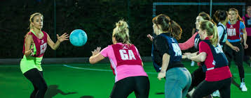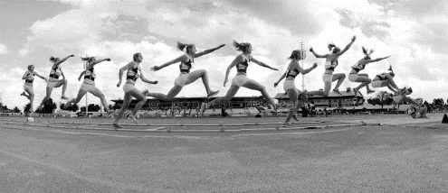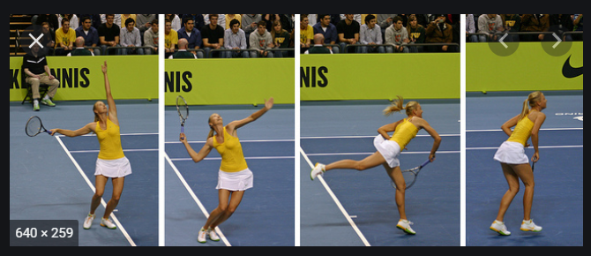

**Applied Anatomy and Physiology**

This first task is to recap the basics for anatomy and physiology, you will have covered these two systems as part of your GCSE work. This is a good starting point before we look at these in more depth.

**Task –** Please create a PowerPoint detailing the effects and benefits of long-term exercise on the body systems.  Please use the following as guidance for what we are looking for.

**Musculoskeletal System**

* Bone density
* Ligaments and tendons
* Muscular hypertrophy
* Rest for adaptions and recovery

**Cardio-respiratory System**

* Resting heart rate
* Recovery time
* Resting stroke volume
* Cardiac output
* size and strength of heart
* Number of blood cells
* Resting blood pressure
* Lung capacity/volume and vital capacity
* Number of alveoli
* Strength of diaphragm and intercostal muscles

**Final Task – Strategies to stop the use of doping and illegal drugs**

Have a good look at the World Anti-Doping Agency website <https://www.wada-ama.org/en/who-we-are>.

Have a go at the ‘PlayTrue Quiz’ and see how much you already know about the work being done to try and keep sport ‘Drug Free’.

<https://www.wada-ama.org/en/what-we-do/education-prevention>

We hope you have enjoyed the work that has been set for you and we look forward to seeing you in September. 😊