A-Level Politics – Year 11 Transition
You are required to complete ALL of the activities that make up the transition work for A-Level Politics, for submission in the first week of the new academic year. The A-Level in Politics is a fun, embracing yet challenging qualification. It will develop your thinking skills and vastly expand your knowledge of politics both in the UK and in the wider world. There will be nine taught hours per fortnight. It is expected that students do three to five hours per week of independent study at home and during their approximately 20 fortnightly free periods.

Politics in the UK
This is a detailed and comprehensive assignment. Do not rush it. We advise that you complete different parts of the transition pack at different points in the Summer holiday, rather than leaving it all until the final week of your break. You should expect to spend longer on these tasks than any homework you have completed before. A-Level Politics will be a significant step up from the work you have completed in Year 11.
Task One – People in Politics
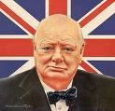
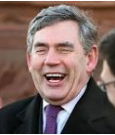
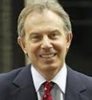
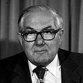
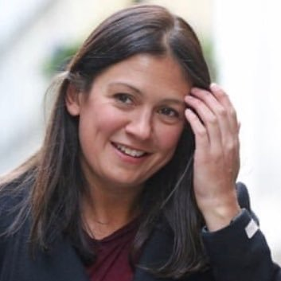
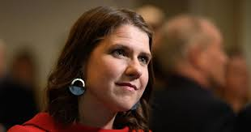
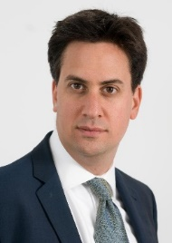
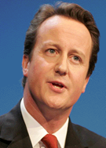
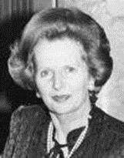
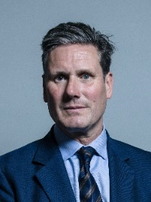
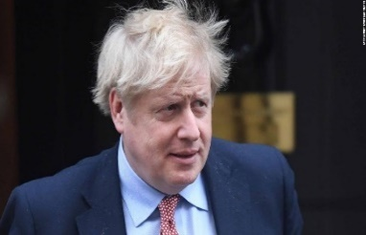
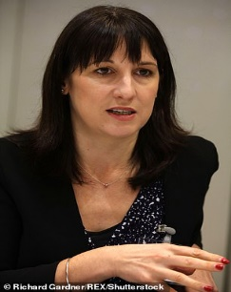
Look at the photographs of some past and present British politicians. You must identify who they are, which party they belong to and whether or not they are/were Prime Minister (PM) or Leader of Her Majesty’s Opposition (HMO). If you are unable to identify any of these people, do some research or ask a member of your family – your parents will remember many of these faces, and some of them might be better suited even to your grandparents!

Task Two – News and Elections
Politics is a subject which cannot be unplugged from news and current affairs. Twitter is seen by some to be the future of Politics – it is used by journalists, politicians and politicos alike to share news and information as well as discuss political issues. When you see an interesting article, follow the links and see where they take you. Among other things, it will be up to you, on this course, to make decisions about political issues, such as whether Twitter and other social media platforms, as they are being used, are appropriate places to air important political discourse. You will also be able to decide whether it is the place of Government to legislate for or against these platforms; how they should work; do they have a place in a democratic society, and if so, how should that place look? Some of the Twitter accounts that follow political events are noted below.
- Your first sub-task is to follow some of these accounts and try to decide what sort of information they giving you: news, fake news, well-formed, or ill-informed opinion? Can you, or should you trust them to help or hinder the formation of your political opinion?
@BBCNews / @SkyNews (or any other news station of your choice – or even more than one!)
@GuidoFawkes
@Briefings_Brit (Briefings for Britain – A group of academics commenting on political issues, not a political party or affiliated with a political party)
@bbcquestiontime (the UK’s most-watched political talk-show: BBC Question Time)
@BorisJohnson (prime minister)
And a range of political journalists like Julia Hartley-Brewer; Andrew Neil
- Your second sub-task is to keep an eye on these Twitter accounts (as well as wider sources – the news and shows on TV, newspapers and others) over the Summer holidays and make a note of any particularly interesting news that is relevant to Politics in the UK. You may even find some stories which are interesting internationally. What conclusions can you draw from what you are learning?
Task Three – British Political History
You need to create an A3 or A4 Political History timeline for the UK. On your timeline you should include a number of features such as:
- The signing of Magna Carta
- The opening of the House of Commons
- The introduction of the Bill of Rights
- The Act of Union
- The Representation of the People Acts
- The European Communities Act
(but not necessarily ONLY these – and for an A grade extension, include the dates at which major UK political parties were founded)
This will be the focus of the first topic we will study next year.
Task Four – Parties and Issues
To start, you should research the Conservative, Labour and Liberal Democrat parties. What do they stand for? Then, use the Internet, textbooks and your imagination to create your own political party which will stand at the next election.
You should include the party’s name, some points as to what the party stands for and three key policies your party will introduce if they are elected, including why you would introduce them. Remember POLICIES COST MONEY: how will your policies be paid for? Will you increase taxes? By how much? Will you, or can you, make savings elsewhere? You have to justify your decisions.
Some topics to consider might be:
Health
Crime
Housing
Education
Defence

