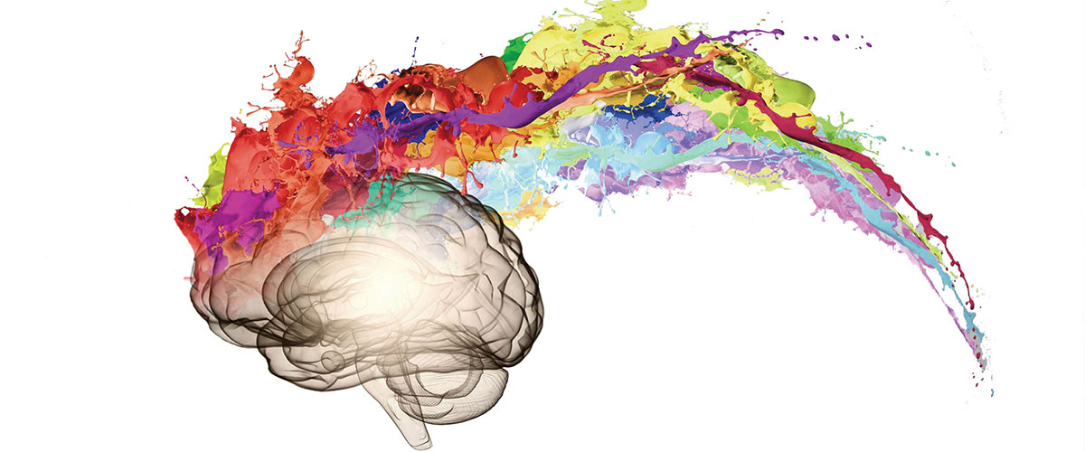
Transition work A Level Psychology

A guide to help you get ready for A-level Psychology featuring
- Books to read
- Films and TED talks to watch
- Podcasts to listen to
- Activities involving note taking skills to prepare for all your subjects
- Topics to research to engage in Psychology
- Online learning courses to prepare for A Levels and beyond
- Day Trips to go on (COVID restrictions allowing!)
- Revision of GCSE Science and Maths that link directly to A Level Psychology
This pack contains a programme of activities and resources to prepare you to start an A-level in Psychology in September. It is aimed to be used after you complete your GCSEs and throughout the remainder of the summer term and over the summer holidays to ensure you are ready to start your course in September.

You could read these:

These books are all popular books about psychology, and great for extending your knowledge and understanding.
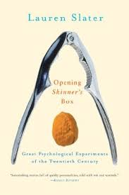
In Opening Skinner's Box, Lauren Slater sets out to investigate the twentieth century through a series of ten fascinating, witty and sometimes shocking accounts of its key psychological experiments. Starting with the founder of modern scientific experimentation, B.F. Skinner, Slater traces the evolution of the last hundred years' most pressing concerns - free will, authoritarianism, violence, conformity and morality.

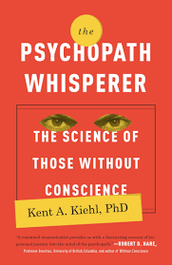
We know of psychopaths from chilling headlines and stories in the news and movies from Ted Bundy and John Wayne Gacy, to Hannibal Lecter and Dexter Morgan. As Dr Kent Kiehl shows, psychopaths can be identified by a checklist of symptoms that includes pathological lying; lack of empathy, guilt, and remorse; grandiose sense of self-worth; manipulation; and failure to accept ones actions. But why do psychopaths behave the way they do? Is it the result of their environment how they were raised or is there a genetic component to their lack of conscience?

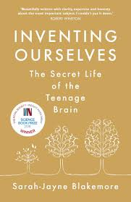
Drawing upon her cutting-edge research Professor Blakemore explores: What makes the adolescent brain different? Why does an easy child become a challenging teenager? What drives the excessive risk-taking and the need for intense friendships common to teenagers? Why it is that many mental illnesses – depression, addiction, schizophrenia – begin during these formative years. And she shows that while adolescence is a period of vulnerability, it is also a time of enormous creativity and opportunity. An amazing book that Mrs B loves!

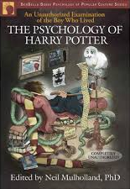
If (like Mrs B) you love Harry Potter, this book is an absolute ‘must read’! The Psychology of Harry Potter, leading psychologists delve into the ultimate Chamber of Secrets, analysing human mind and motivation by examining the themes and characters that make the Harry Potter books the bestselling fantasy series of all time. Do the Harry Potter books encourage disobedience? Why is everyone so fascinated by Professor Lupin? What exactly will Harry and his friends do when they finally pass those N.E.W.T.s? Do even wizards live by the ticking of the clock? Is Harry destined to end up alone? And why did it take Ron and Hermione so long to get together? The article on Attachment types is directly relevant to the A Level specification. This book is available in the St Bernard’s school library.
You could watch these:

What happens when you put good people in an evil place? Does humanity win over evil, or does evil triumph? These are some of the questions we posed in this dramatic simulation of prison life. In 1971, Stanford's Professor Philip Zimbardo conducts a controversial psychology experiment. Twenty four male students are selected to take on randomly assigned roles of prisoners and guards in a mock prison situated in the basement of the Stanford psychology building.
Summary of the real experiment here (29 min): https://www.youtube.com/watch?v=760lwYmpXbc&t=1s
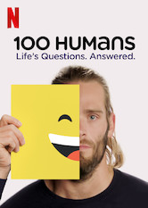

A Netflix series where one hundred hardy souls from diverse backgrounds participate in playful experiments exploring age, sex, happiness and other aspects of being human.

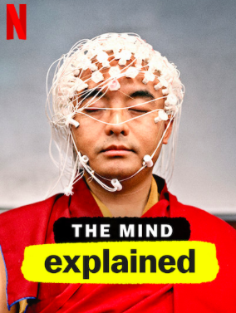

‘The Mind Explained’ is a series is narrated by Emma Stone and examines themes such as what happens inside human brains when they dream or use of psychedelic drugs.
The episodes are aimed to answer popular questions on five topics: memory, dreams, anxiety, mindfulness, and psychedelics.

‘The Real Rain Man’ documents Kim Peek, the genius who inspired Dustin Hoffman's character in Rain Man. Classed as a mega-savant, having memorised 12,000 books, including the entire Bible, he also has autism, finding it hard to do day-today tasks.
https://www.youtube.com/watch?v=DLpCfHH1OVU (46 minutes)

Three Identical Stranglers. Documentary: New York, 1980: three complete strangers accidentally discover that they are identical triplets, separated at birth. The 19-year-olds' joyous reunion catapults them to international fame, but it also unlocks an extraordinary and disturbing secret that goes beyond their own lives - and could transform our understanding of human nature forever.
You could listen to these Podcasts:

Invisibilia explores the hidden forces that shape the way humans think and act. Past topics vary widely, including examinations of emotions, the nature of reality, computers, social norms and personality.

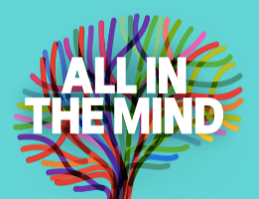
‘All in the Mind’ is a weekly program produced by the BBC explores stories that relate to the potential and boundaries of human psychology.
Past topics include earthquake trauma treatment, astronauts, conspiracy theories and social media.

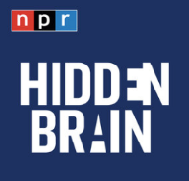
The ‘Hidden Brain’ helps curious people understand the world – and themselves. Using science and storytelling, Hidden Brain's host reveals the unconscious patterns that drive human behaviour, the biases that shape our choices, and the triggers that direct the course of our relationships.
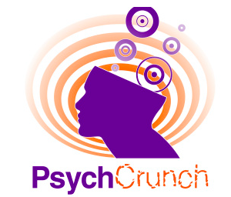
‘PsychCrunch’ is the podcast from the British Psychological Society’s Research Digest. Each episode explores whether the findings from psychological science can make a difference in real life. Just how should we live, according to psychology? They speak to psychologists about their research and whether they apply what they’ve discovered in their own lives.

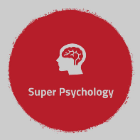
This podcast is specifically aimed at students of A-Level Psychology, but it is also suitable for anyone who has an interest in what Psychology is all about. These episodes will take you through the topics for the A-Level, with each episode focussing on a different part of the specification.
The person who produces this is an excellent Psychology teacher and works for Tutor2u. She also runs a separate YouTube Channel 'Super Psychology'

You could watch one of these TED talks:

1. How we read each other's minds, Rebecca Saxe https://www.youtube.com/watch?v=GOCUH7TxHRI
According to Saxe, a professor of neuroscience at MIT, you don't need tarot cards or ESP to read people's minds. A functioning right temporo-parietal junction will do just fine. In her talk, Saxe explains how this brain region allows humans to be uncannily good at sensing other people's feelings, thoughts, and motivations.
2. The riddle of experience vs. memory, Daniel Kahneman https://www.youtube.com/watch?v=XgRlrBl-7Yg
If you're looking for highly credentialed TED speakers, Kahneman's résumé won't fail to impress. A Nobel Prize-winning psychologist and bestselling author, Kahneman uses his 20 minutes on the TED stage to explain that there are actually two flavours of happiness: the kind we experience in the moment and the kind we experience in our memories. Maximizing your own well-being in life means keeping both in mind.
3. The paradox of choice, Barry Schwartz https://www.youtube.com/watch?v=VO6XEQIsCoM
More choice is always better, right? Not according to Schwartz, a psychologist who argues that having to decide which of approximately 6,000 brands of similar toothpaste to buy "has made us not freer but more paralyzed, not happier but more dissatisfied.
4. Are we in control of our own decisions? Dan Ariely https://www.youtube.com/watch?v=9X68dm92HVI
This talk "uses classic visual illusions and Ariely’s own counterintuitive (and sometimes shocking) research findings to show how we're not as rational as we think when we make decisions.
5. Flow, the secret to happiness, Mihaly Csikszentmihalyi https://www.youtube.com/watch?v=I_u-Eh3h7Mo
In this talk, legendary psychologist Csikszentmihalyi (Mrs B studied his work at university) dares to ask one of life's biggest questions: What makes us happy? The answer isn't fame or money, he insists, but flow -- that lost-in-time feeling you get when you focus intensely on work you're good at.
6. The power of vulnerability, Brené Brown https://www.youtube.com/watch?v=iCvmsMzlF7o
One of the top-five-most-popular TED Talks of all time, this moving account of Brown's own struggles with shame and control weaves together sometimes hilarious personal anecdotes with hard research to convince viewers that forging real connections requires the bravery to be vulnerable.
7. The psychology of evil, Philip Zimbardo https://www.youtube.com/watch?v=OsFEV35tWsg
Psychology isn't all happiness and flourishing, of course. The discipline also delves into the darker sides of human nature and what drives us toward unethical or even downright evil behaviour. That's the topic of this talk by ‘superstar’ Zimbardo in which "he shares insights and graphic unseen photos from the Abu Ghraib trials."
But don't worry, it's not all gloom and doom. He also ‘talks about the flip side: how easy it is to be a hero, and how we can rise to the challenge.’
8. How reliable is your memory? Elizabeth Loftus https://www.youtube.com/watch?v=PB2OegI6wvI&t=405s
Psychologist Elizabeth Loftus studies memories. More precisely, she studies false memories, when people either remember things that didn't happen or remember them differently from the way they really were. It's more common than you might think, and Loftus shares some startling stories and statistics, and raises some important ethical questions we should all remember to consider.
You could learn about How to Take Notes:
Making effective notes in lessons is an essential skill for A-level Psychology. Practice producing notes using the Cornell System by summarising two of the TED talks you have listened to. Complete your notes in the following format and show them to your teacher.
Topic |  | Subject  Date
Lesson Focus

Questions and Cue words | NOTE TAKING  1. Record: During the class (or watching a documentary), use the note-taking column to record the lesson using concise sentences and abbreviations.  2. Questions: As soon after class as possible, write questions in the left-hand column based on the notes in the note taking column. Writing questions helps to clarify meanings, reveal relationships, establish continuity, and strengthen memory. Also, the writing of questions sets up a perfect stage for exam studying later.  3. Recite: Cover the note-taking column with a sheet of paper. Then, looking at the questions or cue-words in the question and cue word column only, say aloud, in your own words, the answers to the questions, facts, or ideas indicated by the cue-words.  4. Reflect: Reflect on the material by asking yourself questions, for example: “What’s the significance of these facts? What principle are they based on? How can I apply them? How do they fit in with what I already know? What’s beyond them?  5. Review: Spend at least ten minutes every week reviewing all your previous notes. If you do, you’ll retain a great deal for current use, as well as, for the exam.
Summary

Here’s a 5 minute video on how to take Cornell notes: https://www.youtube.com/watch?v=WtW9IyE04OQ
You could research some of these topics:
Memory
Memory helps make individuals who they are. Without the help of memories, someone would struggle to learn new information, form lasting relationships, or function in daily life. Memory allows the brain to encode, store, and retrieve information.
Different areas of the brain affect different aspects of memory. The hippocampus, for instance, is related to spatial memory, which helps the brain map the surrounding world and find its way around a known place. The amygdala, on the other hand, is linked to emotional memory.
https://www.psychologytoday.com/gb/basics/memory
https://www.simplypsychology.org/memory.html
Obedience
Obedience is a form of social influence where an individual acts in response to a direct order from another individual, who is usually an authority figure. It is assumed that without such an order the person would not have acted in this way.
Stanley Milgram (1963) wanted to investigate whether Germans were particularly obedient to authority figures as this was a common explanation for the Nazi killings in World War II.
https://www.simplypsychology.org/obedience.html
https://www.simplypsychology.org/milgram.html
Criminal psychology
Criminal psychology looks at the interaction between psychology and criminology and criminal justice. It is concerned with using psychological research and theories to analyse and improve the criminal justice system. Try the ‘You be the Judge’ activity by following this link. YOU hear the case, YOU decide the sentence!
http://ybtj.justice.gov.uk/
Issues in mental health
What do we mean by mental health? Which behaviours should be classified as ‘sane’ or ‘insane’, and which should be medicated or treated non-biologically? Perhaps we shouldn’t treat any mental illness at all and simply accept the diversity of human behaviour? Follow these links to find out more about the explanations and treatments of mental illness.
Drug use and psychotic disorders: https://www.rethink.org/advice-and-information/about-mental-illness/learn-more-about-conditions/drugs-alcohol-and-mental-health/
Virtual reality as a cure for fear of heights: https://www.digitalhealth.net/2020/03/nhs-offers-new-virtual-reality-treatment-for-patients-with-social-anxiety/
Body clock disruptions linked to mood disorders: https://www.bbc.co.uk/news/health-44113414
Regular exercise and risk of depression: https://www.ted.com/talks/wendy_suzuki_the_brain_changing_benefits_of_exercise?language=en

You could carry out one of these MOOCs:
A Massive Open Online Course (MOOC) is an interactive step-by-step course aimed at reaching an unlimited number of participants worldwide to create a community of lifelong learners. There are many different MOOC providers that cover a huge variety of different subject and topic interests.
Typically, a MOOC will involve 2-3 hours study per week for 6 weeks or so. MOOCs are free of charge. All required course materials will be provided for you online, which is also 100% free! Each course is open to anyone with internet access across the world and all you need is your wonderful brain!
I really like the site Future Learn https://www.futurelearn.com/ as I find it the most accessible, but there are others:
Introduction to FutureLearn: https://www.youtube.com/watch?v=aEyjRmCV6ck

Type in ‘Psychology’ into the search to see what courses are available now or in the coming weeks.
Or Browse by subject:

Examples of ones coming up in in the coming months:
Introduction to Psychology (series of different approaches available)
Forensic Psychology: Witness investigation
What is a mind?
The mind is flat: the shocking shallowness of Human Psychology
Consumer behaviour and psychology

You could take a Trip:
There are always lots of places you can visit to help stimulate your interest and knowledge in psychology. Here are a few suggestions.

You could revise your GCSE Science topics that relate directly to the A Level Psychology Specification:
Label the Nervous System
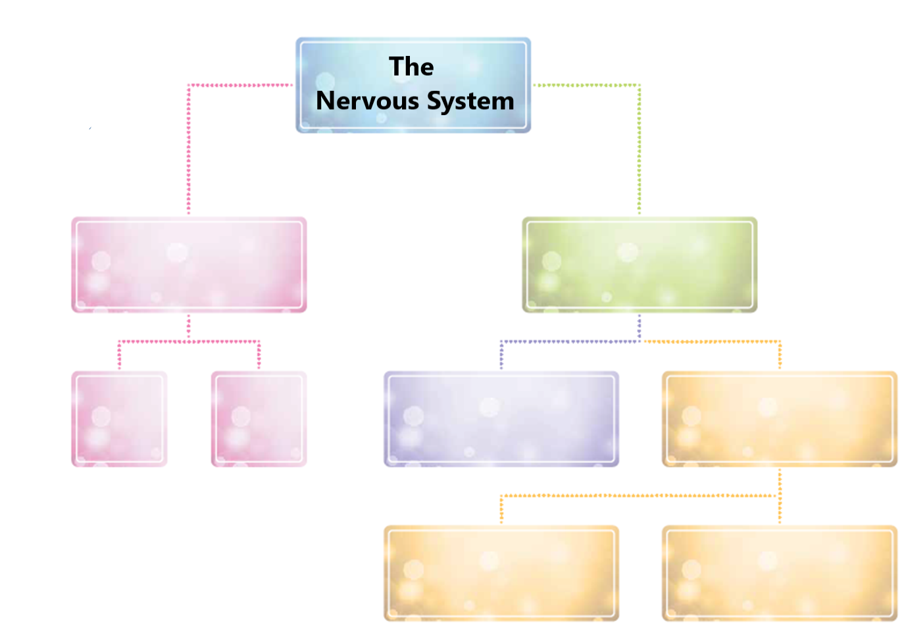

Label the Neuron
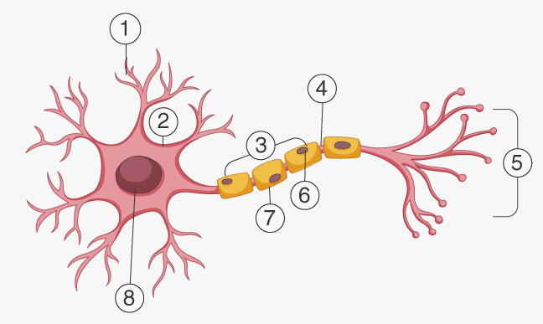
Label the synapse:
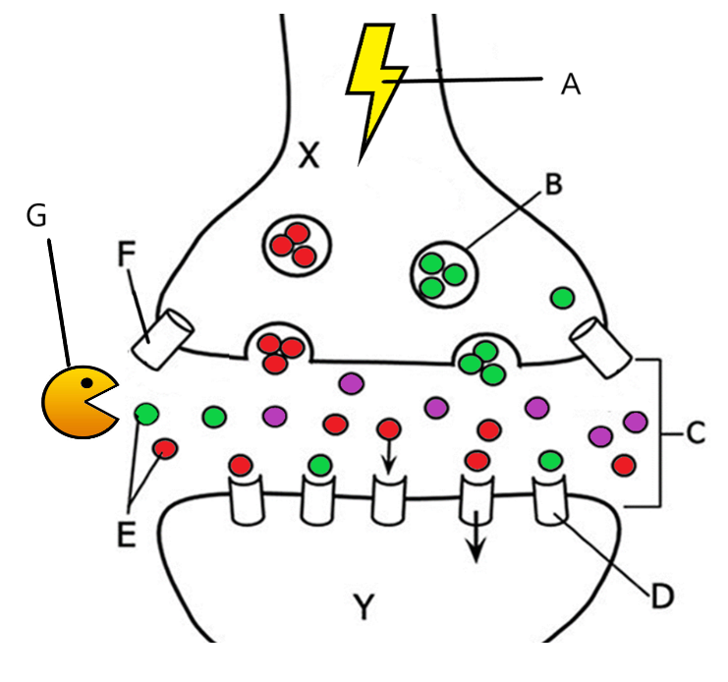
Label the glands in the body and find out their role:
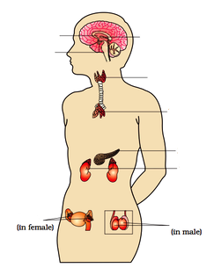
Revise your GCSE Maths topics that relate directly to the A Level Psychology Specification:
In Psychology about 10% of the marks available are maths skills – in terms of overall marks this equates to about a grade. The Maths skills are an equivalent level to that of Higher GCSE Maths/Stats– these pages are to help you become more familiar with some of the mathematical content that you will need to know for the course.
1) Standard form:
Sometimes psychologists will come across very large or very small numbers. Because of the nature of very large numbers, it is often necessary to simplify these using shorthand, this is known as standard form.
Write in standard form
a) 70 × 105 b) 40 × 105 c) 0.8 × 106
d) 0.4 × 108 e) 0.3 × 108

2) Rounding to decimal places
Round to 1 decimal place
a) 0.374 b) 0.798 c) 0.393
Round to 2 decimal places
d) 0.136 e) 0.138 f) 0.464

3) Rounding to significant figures
Round to 1 significant figure
a) 15 b) 983 c) 0.0097
Round to 2 significant figures
d) 0.133 e) 0.0403 g) 90054

4) Using percentages, fractions and decimals
Convert to a decimal
a) ½ b) ⅞ c) 65%
d) 153% e) 51.6% f) 41%
Convert to a fraction, reduced to simplest form
g) 0.2 h) 0.62 i) 90%
Convert to a percentage
j) 0.87 k) 2.11 l) 0.017
5) Ratios
Simplify
a) 5 : 10 b) 15 : 5 c) 5 : 50
d) 52 : 56 e) 52 : 12 f) 52 : 56
g) 18 : 22 : 12 h) 16 : 52 : 48 i) 42 : 15 : 24

Sample question
The findings from the study are presented below:
A table to show the number of participants who perceived the ambiguous image as a monkey or as a teapot from both conditions: image presented with animals and image presented with kitchen items.
 | Perceived as a monkey | Perceived as a teapot
Presented with animals | 15 | 10
Presented with kitchen items | 5 | 12

a) Identify and simplify the ratio of the number of participants who perceived a monkey in the first condition and the number who perceived a monkey in the second condition.
b) Identify and simplify the ratio of the number of participants who perceived a teapot in the first condition and the number who perceived a teapot in the second condition.

6) Measures of Central tendency.
a) Find the mean of the data given below.
6 6 1 2 1 8
mean =
b) Find the mean of the given data below, rounding your answer to the nearest whole number.
11 12 28 17 21 24 27
mean =
c) Find the mean of the given data below, rounding your answer to 1 decimal place
11.9 4.8 16.4 18.2 12.3 3.6 2.8 25.6 10.8 0.6
mean =
d) Find the median of the data given below.
15 20 10 15 14 23 14
median =

e) Find the median of the data given below.
23.1 11.1 13.1 30.9 13.5 18.1 14.1 0.3
median =
f) Find the median of the data given below
26.3 18.6 8.8 23.2 29.3 20.9 1.5 0.2
median =
g) Find the mode of the data given below.
1 4 6 2 10 11 12 8 10
mode =

Sample question
A Psychologist investigated whether recall was affected by the way the material was presented. One group was given pictures to recall, the other group were given words.
Calculate the measures of central tendency for the following set of raw data.
Number of pictures recalled | 7 | 5 | 10 | 8 | 7 | 5 | 7 | 9
Number of words recalled | 4 | 6 | 7 | 5 | 6 | 5 | 9 | 3

Condition 1 (Numbers of pictures recalled)
a) Mode = b) Median = c) Mean =
Condition 2 (Number of words recalled)
d) Mode = e) Median = f) Mean =

7) Displaying Data
Graphs, charts and tables are all used to describe data and make it easier for the data to be understood. There are a number of graphs and charts that you need to be able to draw and interpret, they include:
• Tally chart (frequency table) • Line graph • Pie chart
• Bar chart • Histogram • Scatter diagram

Sample questions
A researcher is investigating gender differences in classification of attachment. They conduct a study using Ainsworth’s ‘Strange Situation’. The results are shown in the figure of the next page.

The proportions of boys and girls who are classified as securely attached
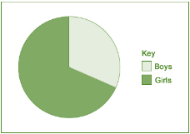
(a) Using the information in the figure, estimate the percentage of boys and girls that are securely attached.
Boys = Girls = (2)
(b) In a different study, 150 children were classified as securely attached. Of these, 40% were boys. How many of the 150 children were girls? Show your workings. (2)

A psychologist thinks that there may be a link between language ability and institutionalisation. She tests the language skills of 8-year-old institutionalised children. A high score on the test indicates good language ability and a low score on the test indicates poor language ability. She also records the number of years that each child has been institutionalised. The findings are shown in the figure below.
The relationship between time spent in institution and language score
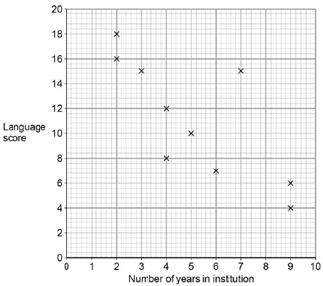
(c) Identify the type of graphical display in the figure.
A Histogram B Bar graph C Line graph D Scattergram (1)
(d) How many children took part in the study? (1)
(e) What does the pattern of data in the figure suggest about language ability and institutionalisation? (2)
(f) Calculate the range for the language scores. Show your workings. (2)
Your Summer Task …
To make sure you are fully prepared for A-level Psychology, you may want to carry out some tasks to complete over the summer holiday.

 Complete your Cornell notes on one of the TED talks you have watched. (Do watch more, but you don’t need to make notes on them unless you want to!)

 Read at least one of the suggested books and summarise what you learned from it. (only if you are able to access/obtain the book)

 Watch at least one of the suggested films/shows and listen to at least one episode of a podcast.

 We will be discussing the books and films when you come back in September, so make sure you don’t forget what you have read and watched!

 Extend yourself and try a MOOC – there are plenty to choose from online.

 Visit the Freud Museum or attend a talk on psychology – lots of universities provide free events. (I usually set this, but during the COVID-19 shutdown, this is not possible. Perhaps when we break free!)

 Complete the GCSE Science and Maths revision pages

Start to engage with and enjoy the world of psychology, starting with the ideas in this pack! It’s a fantastic subject, and I can’t wait to see you in September! Well done for choosing Psychology at St Bernard’s!

