St. Bernard’s High School
Religious Studies
Transition Work

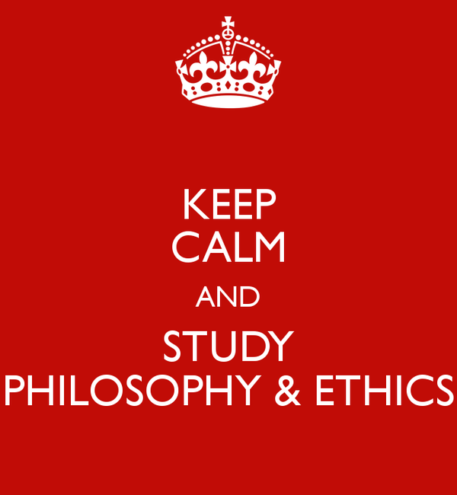

Name: …....................................

Welcome, Year 11!
This is your transition work for A-Level Religious Studies, which you are thinking about taking at A level this September, and good decision at that! The pack is designed to give you a flavour of what A-Level Religious Studies is all about. The course at St. Bernard’s is made up of three parts: Philosophy of Religion, Ethics and New Testament Studies. The pack will introduce you to some core philosophical and ethical concepts and events, to aid your understanding ready for Sixth Form.
Don’t feel you need to complete it all in one go!

Task One:
What is Philosophy and Ethics?
Go to the two links below:
Watch each of the videos one at a time. We recommend watching it once fully without making notes and then a second time to be able to write things down that you found.
- What is Philosophy (Crash Course) https://www.youtube.com/watch?v=1A_CAkYt3GY
- What is Ethics?
https://www.youtube.com/watch?v=u399XmkjeXo
- Now, summarise the main ideas of each video in the space below:

Task Two:
Ancient Greek Influences on Philosophy of Religion

Plato: An Introduction

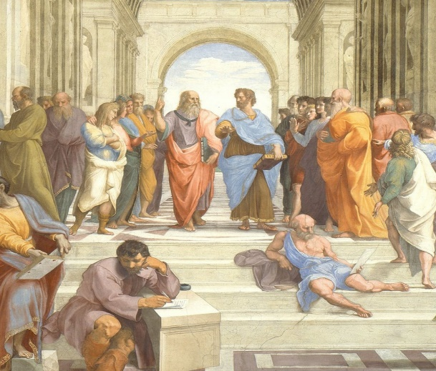
Plato was an Ancient Greek philosopher who lived from 427 – 347 BCE, and a former student of the great philosopher Socrates. Plato is perhaps one of the most influential and well-known philosophers in history. His work influenced the development of philosophy throughout the Western world. His early works are about Socrates' philosophy and most of Plato's books feature Socrates as the leading character. In his later works, Plato wrote about many issues; including the existence of the soul, the nature of beauty and theories of governance. Plato founded his own school of philosophy called the Academia (from which we get the word 'academy' in English).

Theory of Forms

In your head, imagine a cat. It might be white, black, ginger, tabby...the list goes on. Was your idea of a cat exactly the same as your neighbour? Probably not, but there are a set of characteristics that you will both have imagined: a tail, whiskers, four legs, paws. These characteristics resemble the idea of what a cat is. You would both be able to recognise a cat if one walked past you, even if it didn't look exactly the same as the cat you imagined.
Plato saw a very important distinction here: the world of appearances and the real world. He proposed that the world we live in is a world of appearances, but the real world is the world of Forms. Forms are the idea of what a thing is, like the idea of a cat. All cats that exist in our world, the material world, conform to the idea, or the Form, of a cat. A Form does not change, it is a concept that is everlasting. Plato argued that the true Form of everything (including cats!) must exist somewhere, in a different reality; he called this the world of Forms.

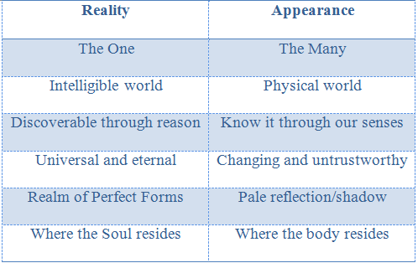

As a great philosopher, Plato wasn't all that interested in discussing the Form of a cat. He focused more on concepts like beauty, truth and justice. He saw that concepts like beauty can be applied to all sorts of different things. Both a person and a piece of music can be beautiful, and so reveal some characteristic of beauty.

But neither clearly define beauty, because they are different, and other different things can be beautiful too (like a painting or a landscape).

This led Plato to suggest that there was a Form of beauty, to which all these things correspond to some extent.

In our world, there are only the shadows and images of the Forms. Material things in our world imitate a form. As our understanding is limited to the objects that exist in our material word, the Forms go beyond human comprehension. So how do we recognise the Form of beauty in a beautiful person?

Plato argued that the reason we recognise the Forms is because when we are born we have a dim recollection of them. He said that there is an inner part of us, that most people call the soul, which is immortal and unchanging. Before the soul became tied down to the body, it was connected to the real world of Forms. The reason that we can all recognise beautiful things or kind acts is because we have all seen the Forms before. Plato’s evidence for this claim was the fact that a person can instinctively know that something is beautiful, even if we haven’t been taught it.
Therefore, Plato concluded, it must be true that we have an immortal soul which was once part of the world of the Forms.

Thought Point

The Philosopher: Plato said that the philosopher is someone who tries to escape the world of appearances and with their mind see the Forms that lie behind appearances. As a true philosopher has knowledge of the Forms, he argued that they are the most suitable people to rule society.
Do you agree?

The Form of the Good

Plato believed that some things do not conform to a Form, like number and evil. He also thought that some Forms were greater than others; universal qualities like justice, truth and beauty. These ideal Forms all have something in common – they all have the presence of Good in them. Therefore, Plato said that Good is the most important Form. It is ‘the Form of the Forms’ (or ideal of the ideal Forms).
Plato argued that once you can understand Good, then you can understand all other Forms because they are all aspects of goodness. The Good is like the Sun: it illuminates everything else, and the further away you get, the paler things become. In his analogy of the Sun, Plato says that the Form of the Good makes things knowable, and that it is the source of the other Forms. Therefore, knowledge of the Good is the highest knowledge a human is capable of. An ordinary person struggles to see past the illusion of this material world because they are ruled by their senses. Only the person who questions and investigates can learn the truth behind the illusion. Who is that person? The philosopher, of course!

Plato’s Analogy to Sight:
Sight requires both light and the eye to see clearly. Light symbolises the Form of the Good. Plato’s implication is that without the knowledge of the Form of Good one does not see clearly; the same as trying to see in complete darkness.

Activities
1. Write a definition of the Forms.
2. Explain why Plato says the world we live in is not the real world.
3. How do you explain the fact that everyone is able to identify something like kindness?
4. What would you say to challenge the idea that the recognition of Form proves we have an eternal soul?

Analogy of the Cave

The Analogy of the Cave is one of the most famous passages from Plato’s Republic. Plato uses this analogy, and two others, to illustrate his theory of Forms. The Cave is often said to be allegorical, which means that different elements of the story are symbolic of the situation in which people find themselves.

Imagine people sitting on chairs in a cave. They are all facing the wall of the cave. They are chained to chairs. The only light in the cave comes from a fire. There is a wall behind the prisoners and there is a fire located behind the wall. Behind this wall, other people are walking up and down and carrying statues on their heads. What the prisoners chained to the chairs see is the shadows cast by the statues on the wall in front of them.
The prisoners believe that the shadows are reality because that is all they see. If they hear people behind the wall speaking they assume that these voices come from the shadows.
Imagine if one of the prisoners is freed. At first when he is turned around, he is confused. He doesn’t understand what he sees. Slowly, his eyes become accustomed to the firelight and he can see the statues. He is confused still – he believes the shadows are reality.
Then, the released prisoner is dragged up a long ramp at the back of the cave, and emerges into sunlight. The sunlight is blinding, and so he tries to flee back into the cave. Imagine that someone prevents him from fleeing, and slowly his eyes adjust. He is able to see the world around him. Finally, he looks up and realises the importance of the sun. He sees that it supports life and the seasons. Now, he doesn’t want to go back underground.
However, he might remember his friends in the cave, and want to go back and teach them about reality. When he gets back in the cave, his eyes cannot adjust to the darkness and he cannot see clearly. When he tells the other prisoners his story, and they see he cannot see in the darkness, they decide it is better not to go above ground and wish to put to death anyone who tries to free another prisoner.

Plato’s analogy of the Cave demonstrates the importance of questioning everything in order to distinguish between the material world and the real world. In the analogy, the prisoner who is freed is representative of a philosopher. He breaks away and makes the journey out of the cave to find out what is really going on. In the outside world he discovers the sun and realises it gives life to everything.

In the analogy of the Cave, the prisoner returns to those still inside the cave. This journey is representative of a philosopher educating others about the real world. Once they have learned the truth, they have a duty to return to the Cave and challenge the ideas of reality. However, upon his return the other prisoners want to kill him. This can be seen as representing society’s unwillingness to question what they are told, something that Socrates did. Plato undoubtedly had in mind the fate of Socrates, who challenges the ideas of his day and was condemned to death.

But what is real? Everyone in the analogy is convinced that what they are looking at is real. The prisoners’ knowledge is based entirely on their sense of sight and sound, and they accept this as reality. Plato is showing us that empirical knowledge (gained from the senses) cannot be accepted as fact; it does not show reality. Contrast this to the idea of the freed prisoner. After emerging into the real world, he uses his power of reasoning to reach a philosophical understanding of the truth. This knowledge of reality based entirely on reasoning is called a priori – gained wholly from logical reasoning and independent of sensory experience.
Plato’s argument is absolutist; it is fixed. He believed his argument to be true for all people in all places at all times. It is universal.

Arguments in Support of Plato:

Plato makes a good point that empirical knowledge can be flawed (as was shown by the prisoners thinking the shadows to be real), this is because we live in an imperfect world of appearances and imitation of the Forms. The better type of knowledge is logical reasoning (a priori) as it is based on philosophical reason not our suspect senses. Plato gives a reason for the imperfections of the world which we see all around us, admits the world is imperfect copies of the world. We recognise these imperfect copies of the Forms as we lived there before.

Criticisms of Plato’s Argument:

There is an unclear link between the World of Appearances and the Forms. The cave analogy doesn’t tell us how they are connected. E.g. movement from imitations -> Forms...is there anything in the middle?? How does one actually realise the truth and the reality of the Forms in order to become enlightened? Plato mentions that the hard journey out of the cave is analogous to the soul leaving this world. That may mean a person must die in order to realise the Forms. So how can a person come back and tell the people inside the cave if he is dead? Or does it mean we can realise the truth while being here, but how does one do that? But Plato’s argument is Absolutist (i.e. it is fixed and universal truth for all in all time). But not everyone may accept this, certainly Aristotle didn’t. Aristotle was critical of Plato’s argument because he could not agree that the form of something has a separate existence over and above the particular. No concrete proof that world in cave or outside is real. How can you prove the prisoners and philosopher is right or wrong? Just because someone is philosophically enlightened and intelligent, does that necessarily make them perfect for leadership? For example, there is a common stereotype that really clever people have low common-sense and empathy for less intelligent people, but a leader needs to know his/her people to be a good leader.

Think about this statement and give your view in the space below.

‘If the cave dwellers are happy in their ignorance, it is better to leave them to it’

Do you agree?

Task Four:
Key scholar research

In Philosophy and Ethics you will be introduced to many scholars to support arguments you make in your essays. Create some sort of leaflet/flyer about your chosen scholar.

In this you need to make sure you have completed the following success criteria:
- When were they alive?
- What key books did they write?
- What key issues did they write about?
- Are there any key quotes?

The following scholars to choose to research from are:
- Aristotle
- St Augustine
- St Thomas Aquinas
- Richard Swinburne
- Joseph Fletcher
- Jeremy Bentham

