Things to do to prepare yourself for Year 12
Name:……………………………….
In A-level Textiles, you are expected to respond maturely to a given or self-written brief using a wide range of equipment and techniques that tells the story of how you came to create a suitable outcome. Studying Textiles will give you the opportunity to learn new techniques as well as perfect old ones.
Following the suggestions below will help ensure that you are prepared and ready to start the year when we return to school.

PREPARATION
If possible, invest in the following things below:
- Sewing equipment: Sewing needle/Embroidery needle, scissors, thread, etc.
- Drawing equipment: pencil, eraser, fine liners, etc.
- Colouring equipment: colouring pencils, felt tips, watercolour palette.
- Sketchbook: A3 ring bound is best – you could purchase this from the school shop

COLLECTION
Collect bits and bobs to create unique pieces of work in your book. This will help you to develop your own personal style. In Year 12, you will be expected to not only explore with colours and techniques but texture as well. Collecting materials, (even if they are not textiles materials), will ensure that you have a variety of things to work with.
- Think twice before throwing away unwanted clothing, costume jewellery and accessories– collect scraps or old materials, buttons, ribbon, beads, and fastenings to use for embellishments.
- To create various textures in your work you can collect – bubble wrap, special paper, wrapping paper, newspaper/ magazine cuttings, envelopes, unwanted books and clothing tags.

EXPAND YOUR KNOWLEDGE ON ARTISTS/DESIGNERS.
- Don’t just look at Textiles artists, explore other art forms that you could be inspired by e.g. fine art, contemporary art, illustrators, sculptures, 3-D art, Photography, Fashion editorials, etc. Make a note of any sources that you would like to work in the style of for your coursework.
- Use Books, Pinterest, Google, https://www.textileartist.org/ and the Embroidery magazines to find new Textiles artists.
- Go out to look for inspiration – for example, Street art, Churches, Nature, etc. Take photos or collect anything that inspires you.
- Visit an exhibition to see work in person. If not possible, do a virtual exhibition tour. The following link takes you to some suggestions on the Royal Academy website. https://www.royalacademy.org.uk/article/9-virtual-exhibition-art-tours-to-watch-online. The “Tom Wudl” and Picasso and Paper exhibitions are particularly good.

To increase your appreciation towards Textiles as an artform, we would highly recommend that you watch the documentary “The Secret World of Haute Couture”.
(Link - https://vimeo.com/99469251). Watching things like this will expand your knowledge and perception of Fashion and Textiles and how it contributes to modern society.
Watching other Textiles/ Fashion shows and documentaries will also help to expand your knowledge in addition to increasing your interest towards this subject.

PRACTICAL TASK
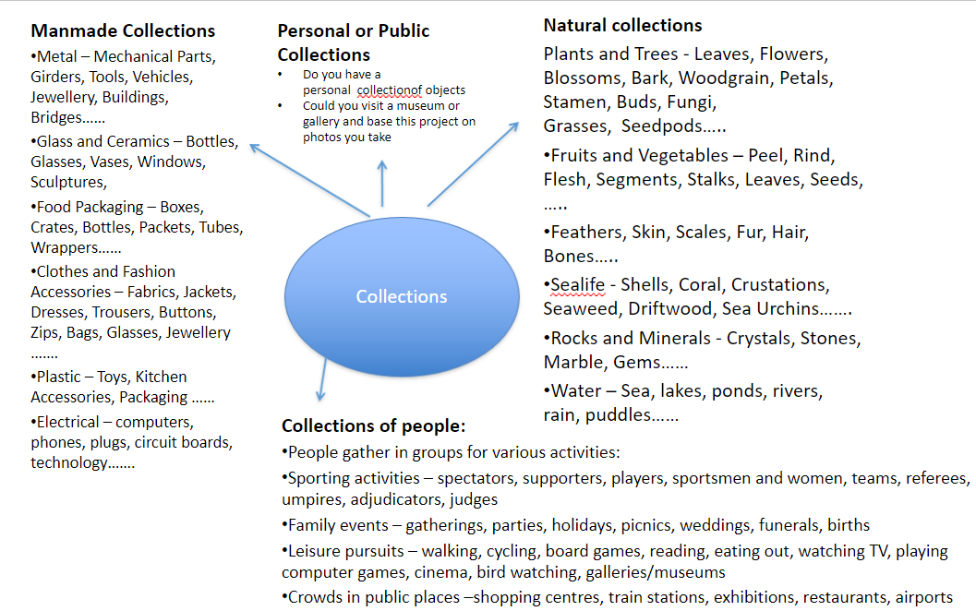
Be prepared for the first project in September, the title of which will be “Collections”. You may interpret this in any way that you choose but will need to select a theme that you can interpret visually. Below are some suggestions of directions you might go in.

- Once you have selected a theme you will need to collect visual information to work from
It is always better to work from primary sources. Photography is a great way to collect primary visual information. Practise using a mobilephone/camera to take photos. Try taking photographs from different viewpoints and think about the composition of the photographs.
Bring a selection of photographs with you in September (on your phone/camera).

- Drawing is an important part of this subject, as this is how you express your ideas and reflections. I would advise sketching, drawing, doodling with a pencil or pen to help you practise your drawing skills. Bring any drawings you do with you in September.
The more you practise, the better you will become!

