ST BERNARD’S HIGH SCHOOL
A Catholic Academy for Arts and Science

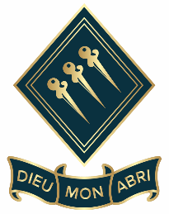

Minibus Driver

Part-time (Monday to Friday, term time only)
Hours are 7am to 9am and 3pm to 5pm
Salary £13 Per Hour
Start as Soon as Possible – Fixed Term to 31 August 2025
Are you looking for a part-time role and have D1 or D1(101) on your driving license? If so, this may be the role for you.

We are seeking to appoint a part-time minibus driver to collect and drop off new Year 7 students to and from school who live in the local surrounding area. No previous experience necessary but it is essential that you have D1 or D1(101) on your license. You must also be DBS checked but the school will do this on your behalf, if you are appointed.

St Bernard’s High School is a vibrant Catholic girl’s school from Years 7-11 with a co-educational mixed Sixth Form. Our school is ranked one of the top schools in Southend, and we are in the top 20% of schools across the country for our progress with students and our outcomes. It is a warm and welcoming school where our Catholic values underpin our day to day life.

All new staff are supported within the positive ethos of this happy and high performing school, and to this end all staff complete an applicable induction training programme. The community at St Bernard’s welcome applications from those of all faiths or none.

Please complete the support staff application form which can be found on our website www.stbernardswestcliff.org.uk under About Us/Vacancies – please note we do not accept CVs

Closing Date: Monday 9 September 2024 @ 9.00am
Interviews: tbc
We do reserve the right to close this advertisement early if we receive a high volume of suitable applications.

Please contact HR Department for further information on recruitment@stbernards.southend.sch.uk

The Governing Body is committed to safeguarding and promoting the welfare of children and young people and expects all staff to share in this commitment.

