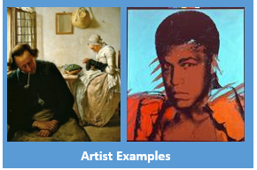
A level Art: Transition work– Year 11

Complete a creative investigation using one of the following themes:
Autobiography
Symbolism
Relationships

Your Tasks:
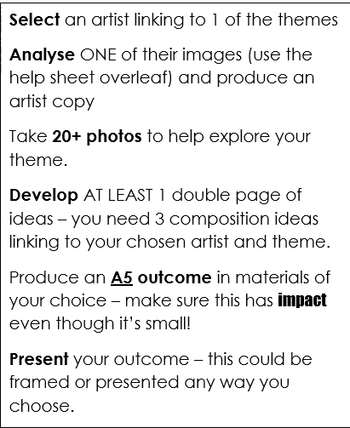
As you complete and analyse your images you can use the questions on slide 2 on the website to help you produce your artists copy.

Actions for your summer:
Analyse one image from the themes above
Take 20 photos to help explore the theme
Develop your double page of ideas
Produce your A5 outcome
Present your outcome

