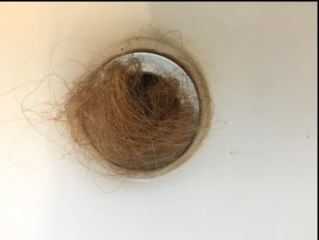**A level Photography: Transition work– Year 11**

**The tasks you need to complete are below. Please use the ppt attached on the website to help inspire you and give further details on the tasks below:**

**Actions for your summer:**

Complete Task 1

Complete Task 2

Complete Task 3

Complete Task 4