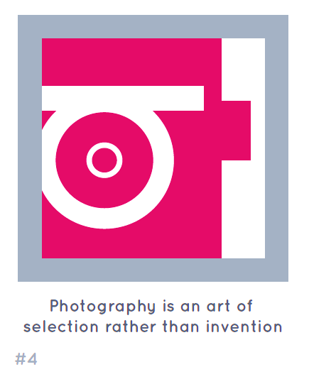**A level Photography: Transition work– Year 11**

As the subject is new to you, demonstrating a critical and contextual understanding of photography may be tricky. The following activities have been designed to help you to reflect on what you already know. Additional research of the prompts will further develop your understanding of photography.

1. **Make and title a PowerPoint called ‘What is Photography?’**
2. **Creatively present your main thoughts, to the following questions (Present on as many slides in the PowerPoint as you wish):**

* Why do people take/make photographs?

**CHALLENGE QUESTIONS**

Think carefully about *YOUR* relationship to photography. What does it mean to you? What interests or intrigues you about it? What questions do you still have about photography? What confuses or irritates you? What do others say or write about photography that strikes a chord with you?

* Why is photography important?
* What skills do you need to be a good photographer?
* How many kinds of photography can you think of?
* How does photography help us see the world?
* Can photographic images be trusted?
* When would it not be OK to take a photograph?
* How do you know when you've taken a good photograph?
* Are photographers also artists?
* Where is the best place to see photographs?
* What kind of photography interests you most?
* What confuses or frustrates you about photography?

1. **Create an imaginary exhibition of images and present in your PowerPoint:**

Imagine you are the curator of a photography exhibition with the title **'What is photography?'** You can choose any number of images to represent your understanding of photography. These images can be any type of photography from any time in the history of the medium. Present your exhibition of chosen images in your PowerPoint.

**Note**: Try to be creative about how you do this. For example, you could exhibit the images in your bedroom, invite visitors, provide them a guide to the exhibition, produce relevant publicity materials, print a catalogue with accompanying text, create a video interview with the curator ...etc.

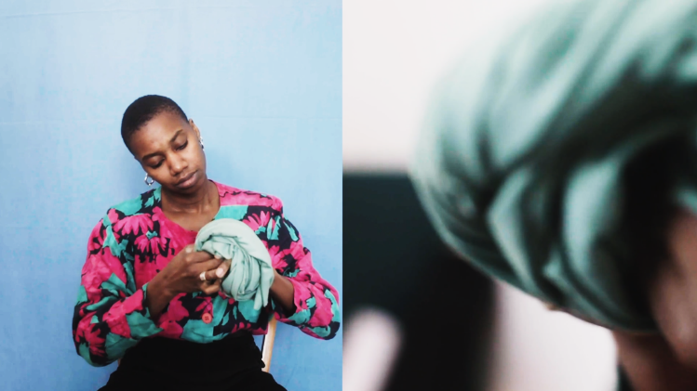





Completed Task 1